Nitrogen as an inert gas in marine applications

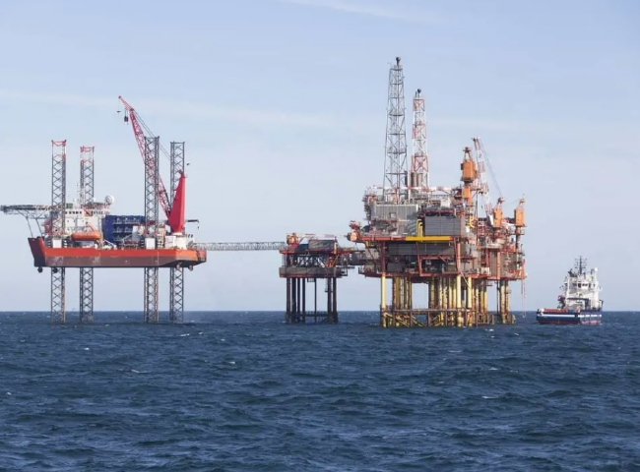
Nitrogen is an inert gas with various applications in oilfield drilling， well workover and oil and gas well completion phases， as well as in pigging and pipeline cleaning.
Nitrogen is used in a wide range of offshore applications， including
Stimulation of oil wells.
Injection and pressure testing
Enhanced oil recovery (EOR)
Reservoir pressure maintenance
Nitrogen loading
Fire protection
Used to support drilling operations， nitrogen is used to inert instrument panels， as well as to inert flare gas， and to purge and test pressure systems. Nitrogen replaces dry air and can extend the life of some systems and prevent breakdowns.
In workover and completion operations， high-pressure nitrogen (using high-pressure booster compressors) is ideal for replacing well fluids to initiate delivery and clean wells because of its low density and high-pressure properties. High pressure nitrogen is also used for production stimulation through hydraulic fracturing.
In petroleum reservoirs， nitrogen is used to maintain pressure as reservoir pressure decreases due to hydrocarbon depletion or due to natural depressurization. Because nitrogen is immiscible with oil and water， nitrogen injection programs or nitrogen flooding are often used to transfer missed hydrocarbons from injection wells to production wells.

