Supply 10m3/h of 99.9% pure nitrogen to the laboratory

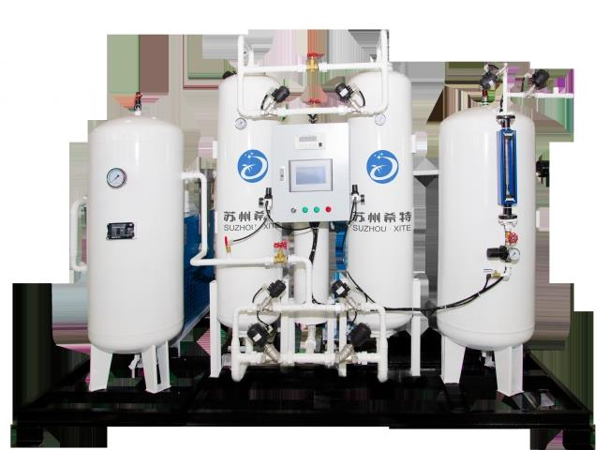
XITE supplied membrane nitrogen production equipment to a world class laboratory. This center is the most important commercial center in China for better research in the areas of lubricants， refining processes， pipeline transportation， alternative fuel fuel additives， engine testing， materials science and environmental science.
The customer purchased the following specifications of membrane nitrogen equipment from XITE
Technology: Membrane technology
Capacity: 10m3/h
Purity: 99.9%.
Application: Nitrogen replacement
Process: Filled nitrogen for gasoline and other lubricants is widely used in many industries to prevent fires， explosions or product degradation during production， storage and transportation. By implementing best practices in a blanket system， you can find opportunities to reduce costs and improve safety.
Humid air in the headspace is replaced with high-purity， inert and completely dry nitrogen. A precision valve control system ensures that as the tank is filled or emptied， the nitrogen content is automatically compensated to maintain protective coverage.
Concentration controlled override
An oxygen monitoring system controls the flow of nitrogen into the tank headspace. The concentration control system helps to achieve precise operation and reduce gas usage compared to continuous purging.
Continuous Purge Coverage
A continuous flow of nitrogen (or other inert gas) is used to maintain a safe oxygen concentration in the tank headspace. Continuous purging is the least optimized nitrogen solution and retrofitting to a pressure or concentration controlled system is recommended.
Pressure Controlled Override
Nitrogen is introduced into the tank headspace to maintain a set pressure. Pressurization with nitrogen professionally minimizes air infiltration and reduces the amount of nitrogen used compared to continuous purging.

