Mixing technology and operation method of liquid gas

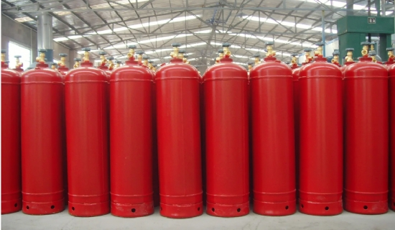
The characteristics of the standard gas should be homogeneous， i.e.， its quantity is guaranteed to be constant within a specified range. Regardless of which method is used to prepare the standard gas， it needs to be homogenized. The mixing methods of standard gases include: heat treatment method， cylinder rolling method， special filling method， natural diffusion method， other mixing methods， etc. Several mixing operations are as follows.
1、Heat treatment method: Generally， the container of the prepared standard gas is heated in a warm water bath below 40℃， so that the gas components can be mixed more quickly and evenly.
2， cylinder rotating and rolling method: the cylinder is placed horizontally on the rolling axis of the mixing half-position， so that it rotates around the axis of the people. The method of mixing takes a short time and is simple to operate.
3、Special filling method: When filling certain gases， the cylinder can be turned upside down and kept at an inclination of 45℃， and inflated from the lower end to promote adiabatic expansion of the gas and produce exothermic effect， and the gas can be mixed evenly while filling.
4、Natural diffusion method: The cylinder filled with standard gas is turned upside down at a suitable position and kept stationary， and the natural diffusion of the gas itself is relied on to achieve uniform mixing， but this method takes a longer time.
5、Other mixing methods: The use of static mixing containers or the use of special construction of the container valve can make the standard gas mix uniformly in a very short time.

