Nitrogen applications in dairy packaging

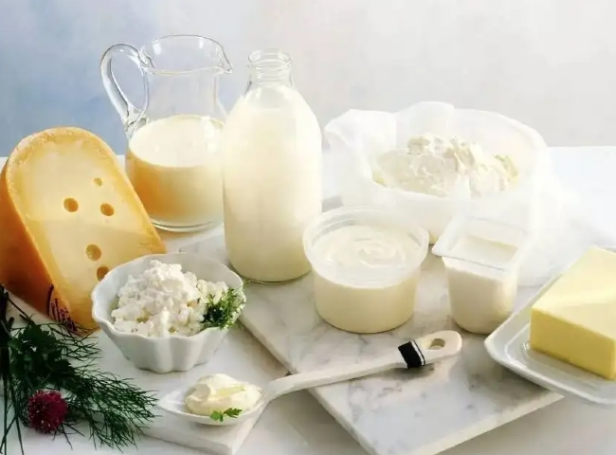
Moisture and oxygen in food packaging have a bad effect on food and cause it to spoil due to bacterial growth. Replacing the air inside the food package with nitrogen means that freshness is maintained and shelf life is greatly extended. In this application， the nitrogen should be pure - about 99.9% pure and very dry. The use of nitrogen also helps maintain the flavor， color， texture and quality of the product.
XITE manufactures precision nitrogen generators that produce nitrogen from the atmosphere. Hundreds of these nitrogen generators have been supplied for the packaging of cookies， snacks， dairy products， milk powder， juices， breakfast cereals and pumpkin pie. These gas generators are automatic devices that produce nitrogen at a cost of 0.3RMB per cubic meter compared to the 1.7RMB per cubic meter cost of nitrogen purchased on the market.

