What is the difference between nitrogen and air in tyres

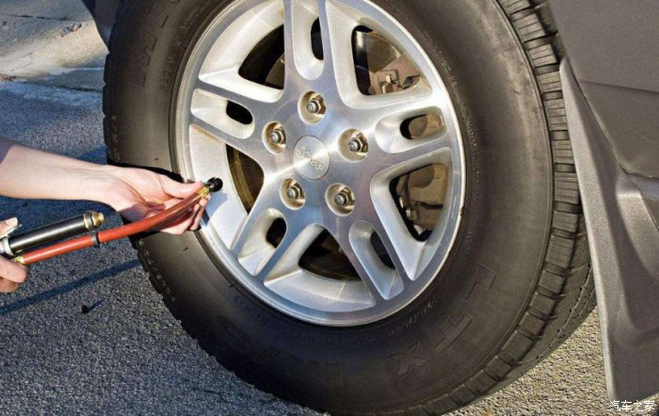
Tyre nitrogen and air difference: 1， the weight is different， nitrogen is lighter than air， about 30 grams lighter， can make the car more fuel-efficient; 2， filled with ordinary air and filled with nitrogen tyre life is different. Ordinary air in the oxygen and tyre rubber and steel wire oxidation reaction within the rubber and steel wire aging， shorten the life of the tyre. Nitrogen due to the molecular activity of small， not easy with the tyre rubber and steel wire chemical reaction， can slow down the aging of rubber.
Air is simply compressed air from the atmosphere into an air compressor， which then inflates the tyre， while nitrogen filling is pure nitrogen to inflate the tyre. Most of this type of tyre inflation is used in major motorsports around the world， and because of the low cost， it was introduced into the passenger car market many years ago.
Compressed air is made up of 78% nitrogen， 21% oxygen and 1% other gases. Compressed air is air that is compressed at high pressure through an air compressor and then released through a pipeline. Compressed air is the source of power for many tools in the workplace， and has many uses， as well as being the most convenient and least costly way to inflate tyres.
Nitrogen is the most abundant gas in the earth's atmosphere and is chemically stable， so it is not susceptible to chemical changes. Because of this， nitrogen is mostly used to fill food packages to insulate them from oxygen， and it is also used in the motorsport sector as the main way to fill tyres.

