Application of nitrogen generator in electronic industry

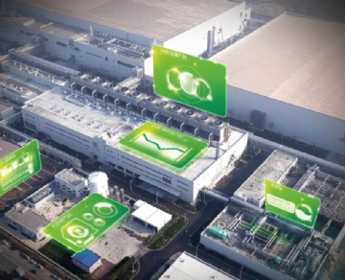
Electronic manufacturing is a diversified field， including everything from surface mount technology and lead-free soldering to semiconductor production. No matter what your main business is， nitrogen generator system can provide many benefits.
Pure nitrogen plays a role in the electronic world in many ways. As an inert， non-conductive gas， it is used to reduce oxidation during assembly and electronic packaging. Let's take a closer look at the many benefits this gas brings to the electronics industry and how the nitrogen generator can help you maximize these benefits.
Reduce oxidation risk
The internal work of electronic equipment requires strong solder joints to ensure quality and durability. However， when welding these products， oxygen particles are often formed， which will lead to oxidation. This is a major obstacle for manufacturers because it weakens joints and leads to product defects and poor overall quality equipment.
However， you can avoid this problem and ensure a better final product by using a nitrogen generator that can produce pure gas in electronic manufacturing. Nitrogen reduces the risk of oxidation by allowing proper wetting between the solder and the equipment using it. This results in stronger solder joints and longer lasting， higher quality products.
Reduce slag
Due to the risk of tin lead solder， many companies choose to use lead-free solder as a substitute. Unfortunately， this option has some drawbacks. First， the cost of lead-free products is significantly higher. In addition， solder has a high melting point， which produces slag， a waste formed on the surface of molten solder. Tin slag needs to be cleaned regularly to ensure quality， which increases the overall cost of using lead-free solder.
The nitrogen generator can reduce the amount of welding slag by more than 50%. This not only improves the quality of the product itself， but also reduces the time for employees to clean up solder dross and waste.
Today， many manufacturing companies are turning to lead-free solder to provide customers with safer products. Therefore， nitrogen is rapidly becoming an important material in the production of electronic products.
Low surface tension
The use of nitrogen in the electronics industry can also increase the productivity of manufacturers and create a more process friendly environment. Specifically， the effect of nitrogen reduces the surface tension of the solder and makes it break cleanly from the welding position. This leads to more efficient manufacturing operations.
Atmospheric consistency
Electronic manufacturing requires very specific environmental conditions， such as temperature and humidity. Because nitrogen is an inert gas， it can provide a more consistent atmosphere in the workplace. Nitrogen keeps the atmosphere stable throughout the day， reducing the chance of errors caused by oxidation and excessive moisture.
Higher quality products and greater savings
By using nitrogen， manufacturers can create higher quality products， which helps to build a good reputation among consumers. From stronger solder joints to more consistent atmospheric conditions and less waste cleaning， the value of using this gas is obvious. However， if you want to maximize the benefits of nitrogen， it is best to invest in a field nitrogen generator for the electronics industry.
When companies switched to nitrogen production， they eliminated the cost of nitrogen delivery services. In addition， they no longer have to wait for the arrival of goods and can use natural gas at any time. Although the price of nitrogen generators is usually high， their return on investment is very high， and many systems can recover their costs within a few months. In addition， once you purchase a generator， the maintenance cost is very low， so you can significantly reduce your overhead.

