Matters to be noted when using high purity oxygen

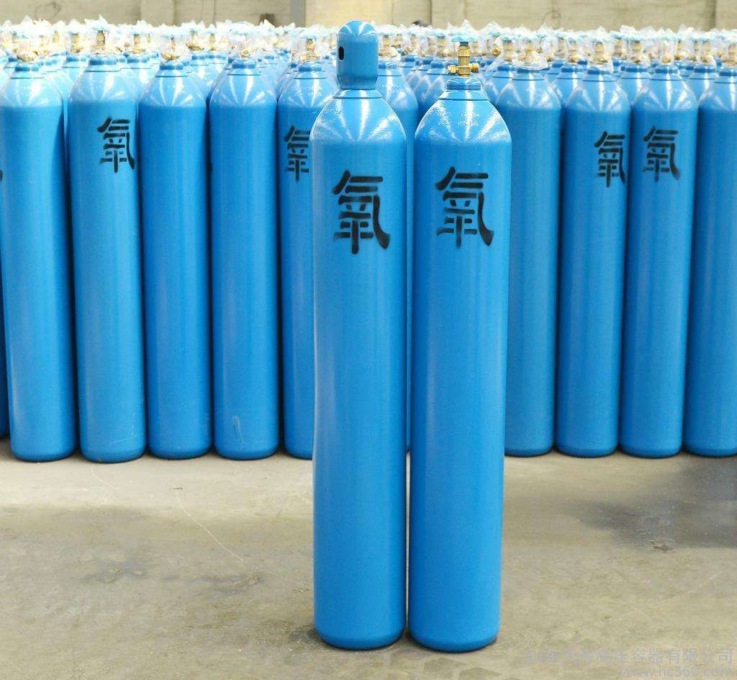
High-purity oxygen is used in the chemical vapour deposition of silicon dioxide; as a source of oxidation and as a reactant in the production of high-purity water; in dry oxidation; and mixed with carbon tetrafluoride for plasma etching. Oxygen's main uses stem from its life-sustaining and combustion-enhancing properties; it has a wide range of applications in metallurgical industrial production. It is also used for water quality treatment. Oxygen is required for all oxidation reactions and combustion processes， e.g.， steelmaking to remove impurities such as sulphur and phosphorus， and combustion of oxygen and acetylene mixtures at temperatures of up to 3，500°C. It is used for welding and cutting of steel. Oxygen is required for glass manufacturing， cement production， mineral roasting， and hydrocarbon processing. Liquid oxygen is also used as rocket fuel， which is cheaper than other fuels.
When using high purity oxygen， you should pay attention to safety， and do a good job of shockproof， fireproof， heatproof， oilproof and so on. High-purity oxygen can promote combustion， should be placed in a cool place， prohibited close to smoke and fire and flammable materials; not in the oxygen table screw mouth smeared with oil; high-purity oxygen cylinder pressure is very high， avoid tipping， impact when handling to prevent explosion.
(1) Carefully look at the marking on the spherical part of the shoulder of the cylinder before use. Especially pay attention to "next pressure test time". And in the process of use in accordance with the requirements of regular technical inspection of gas cylinders. Do not use cylinders that exceed the inspection period.
(2) When using， the first thing to do is to do the external inspection， the inspection focus on the bottle valve， according to the pipe thread， pressure reducer and so on. If you find that there is a leak， slip buckle， needle action or "climb high"， etc.， should be promptly repaired， do not casually deal with. Prohibit the tightening of the valve stem under pressure， adjust the gasket. Check the leakage of gas should be soapy water， do not use open flame. Cylinders and welding in the same use， the bottom of the bottle should be padded with insulating material to prevent the cylinder charged. Pipes and equipment in contact with the cylinder should have grounding equipment to prevent combustion or explosion caused by static electricity. When using the cylinder in winter， the bottle valve or pressure reducer may appear frost phenomenon， or thawing with hot water or steam， it is strictly prohibited to bake with fire or knock the bottle valve with iron， and can not be violently unscrewed pressure reducer adjusting screws， in order to prevent a large amount of gas out of the cause of accidents.
(3) In the process of using and storing and transporting the high-purity oxygen cylinders， violent vibration and impact should be avoided. The cylinders should be loaded and unloaded lightly， and special lifting frames or trolleys must be used， and it is forbidden to use wire ropes to lift the oxygen cylinders directly. When using and storing， the cylinders should be fixed by railing or bracket to prevent tipping.
(4) Oxygen cylinders should be kept away from high temperature， open fire and molten metal splash [more than 10 metres (m) away]. Summer use shall not be exposed to the hot sun.
(5) Open the bottle valve or pressure reducer to move slowly， in order to prevent the injection of high-speed gas flow in the electrostatic spark discharge， solid particles of the collision heat and descending friction heat， gas by the sudden compression of the heat released (adiabatic compression) and so on caused by the oxygen cylinder and pressure reducer explosion and fire.

