Atmospheric Packaging - A Growing Need in China’s Food Industry

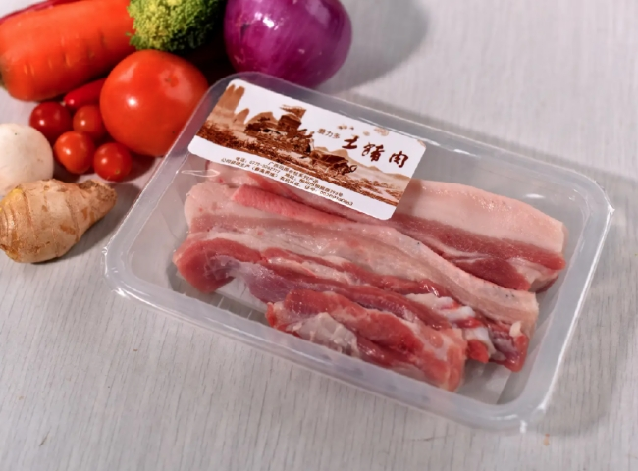
In China， the packaged food industry is growing rapidly. Regionally focused companies have mushroomed in the last 10 years. However， it is still largely an unorganized industry， and the concept of a strong supply and distribution chain has not really penetrated the minds of start-up entrepreneurs. However， as many start-ups reach a point of stability in their business， they are beginning to look at ways to differentiate themselves in the marketplace by having fresher products and fewer returns on the shelf. In addition， the ability to increase the shelf life of products directly affects the bottom line of these companies.
In this educational article， we will explore a technology called modified air packaging (MAP)， which uses nitrogen for packaging， and how it works.
Food preservation and packaging is the process of handling and treating food to stop or slow down spoilage (loss of quality， edibility or nutritional value)， thus allowing longer storage. It requires protection， tamper resistance， and special physical， chemical， or biological needs. It also shows the product labeled to show any nutritional information about the food being consumed.
Preservation and packaging usually involves preventing the growth of bacteria， yeast， fungi and other microorganisms (although some methods work by introducing benign bacteria， or fungi， into the food)， as well as retarding the oxidation of fats that cause rancidity. Food preservation techniques have come a long way， from smoking and canning to eventual general refrigeration and freezing， to help preserve flavor while retarding spoilage and waste.
Lack of quality control during the packaging process may allow water or microorganisms to enter. Most such failures are detected quickly， as decomposition within the packaging material can lead to gas production and eventual package breakage. However， there are also examples of poor production (inadequate processing) and poor sanitation allowing packaged foods to be contaminated with the specialized anaerobic bacterium Clostridium botulinum， which produces acute toxins in the food that can lead to serious illness or death. This organism does not produce gases or distinct flavors and is not detected by the senses of taste or smell. However， its toxin can be denatured by cooking.
Modified Atmosphere Packaging (MAP) is also known as gas flushing， protective atmosphere packaging， or reduced oxygen packaging. Atmospheric packaging allows fresh and minimally processed packaged foods to maintain visual， textural and nutritional appeal. The controlled MAP environment allows food packaging to provide extended shelf life without the need for added chemical preservatives or stabilizers. Processors and marketers of food products rely on aerated packaging to keep products fresh and flavorful， continually meeting consumer expectations for brand quality， consistency， freshness and stock availability.
MAP packaging with longer shelf life allows food processors， food manufacturers， food distributors and food retailers to better control product quality， availability and cost. Longer shelf life allows retailers to eliminate frequent product rotation， removal and re-stocking; thereby reducing labor and waste disposal costs. Distributors can expand distribution territories or offer a wider variety of products to retailers because fewer product changeover requirements allow for growth in other areas.
Food manufacturers are able to take advantage of extended replacement cycles to reduce production replacement requirements. Manufacturing capacity can be more profitably utilized by developing and offering new products.
Today， nitrogen is a key factor in the food manufacturing industry. As a key component of modified atmosphere (the combination of gases within a food package that helps extend shelf life)， it is critical because it helps reduce food costs while ensuring that more food reaches more people who may not have previously had easy access to it. Nitrogen is available in cylinders and in liquid form， and can also be produced on site.
The liquid nitrogen delivered needs to be converted from gas to liquid state first for trucking. It's almost like pouring a glass of water in your kitchen， turning it into ice in the refrigerator， taking this solid block to your living room and melting it so you can drink it. That's a lot of work for a glass of water. In addition， the loss of product from both fill points (loading into the truck at the nitrogen facility and unloading from the truck at the production facility) creates product waste， not to mention additional delivery costs.
Moving to nitrogen production at your site not only offers a tremendous opportunity for cost savings for food production facilities， but is also a sure path to a greener future. Based on current market prices for liquid nitrogen， food manufacturers can reduce their costs by 60-80% when moving to on-site nitrogen production. When considering the capital costs associated with on-site nitrogen production (such as the cost of generators， air compressors， receivers， site preparation， power and maintenance)， customers can realize a return on investment in as little as 1-2 years and will see a nearly 80% reduction in daily operating costs for maintenance and energy costs alone. Weighing the various options and competitive pricing from nitrogen suppliers can add further savings.
XITE has supplied over 500 nitrogen generators for packaging applications. We have a list of most nitrogen generators in the packaged food industry. If you need such nitrogen equipment for your food packaging application， please contact our sales department or send us your inquiry.

