The importance of nitrogen in food industry production

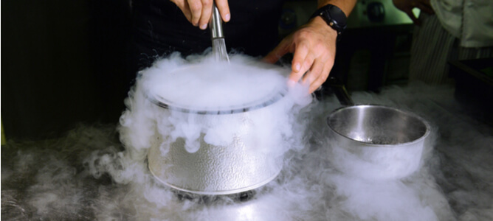
Nitrogen is an important natural resource used in a variety of commercial and industrial applications， including food and beverage manufacturing. Packaging food products with nitrogen has proven to be an effective way to extend their shelf life. In this article， we will discuss nitrogen food preservation methods， as well as the benefits of nitrogen generators for food products.
The Impact of Nitrogen on the Food and Beverage Industry
The use of nitrogen in commercial food and beverage manufacturing has revolutionized food preservation. Because of its inert chemical properties， gaseous nitrogen slows the oxidation process that causes food spoilage.
As a result of packaging food with gaseous nitrogen the shelf life is extended， waste is limited and cost savings are realized for retailers. Store owners can display items that stay fresher longer， while end consumers can store and consume their products long after purchase.
Common uses of nitrogen in food industry production
Nitrogen can be used in a variety of manufacturing industries for different applications. Some of the widely used applications of gaseous nitrogen in commercial food and beverage production are outlined below.
Food Processing
Food processing is a good example of the use of nitrogen in food industry production. A technique called aeration can be used to create food products with specific textures and consistencies. For example， aerated chocolate bars can be created by mixing chocolate with pressurized nitrogen to create a unique micro-aeration effect.
Food Packaging and Storage
Final packaging is critical in commercial food production， as improper packaging can lead to contamination， rapid oxidation and reduced item life. The use of food grade nitrogen generators to inject the inert gas nitrogen into the final food packaging will increase the shelf life of the packaged food.

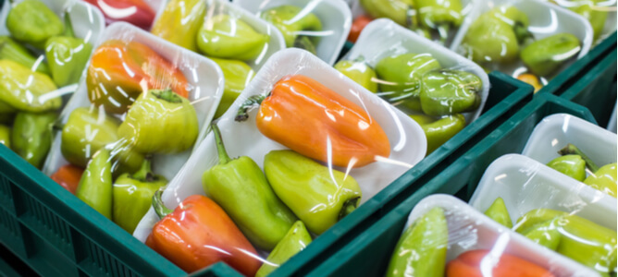
Modified Atmosphere Packaging (MAP)， the replacement of oxygen in packaged foods with nitrogen， is a good example of the effects of processing foods with nitrogen. In addition to longer shelf life， other benefits of MAP include preservation of freshness， aroma， taste and flavor.
Beverage Processing
Beverage production is another area where the use of nitrogen can be beneficial. For alcoholic beverages， gaseous nitrogen can be used to carefully regulate the fermentation process， resulting in high-quality wines and beers with good aromas and flavors.
In addition， some non-alcoholic beverages made from fruits and vegetables are also subjected to a fine conditioning process with high purity nitrogen. In these applications， industrial grade nitrogen with a purity of 99% or higher is typically used.
What are the benefits of on-site nitrogen production for the food and beverage industry?
The useful quantities of nitrogen required for food and beverage production can be sourced from cylinders supplied by suppliers or generated on site at the production site.
While both methods of gas procurement can provide the necessary quantities of gas， on-site nitrogen production has some significant benefits.
Access to reliable nitrogen production technology
Industrial operators who choose on-site nitrogen production can benefit from efficient nitrogen production technologies， including PSA and membrane nitrogen generators. These technologies ensure that consistent， high-purity nitrogen is produced at all times without the risk of production delays often caused by supply chain disruptions to the gas provided by suppliers.

Improve overall industrial safety
By utilizing an on-site nitrogen generator， there is no need to store large quantities of gas for future use， as the required amount is only generated when needed. Therefore， industrial safety hazards associated with nitrogen storage are completely avoided.
Space saving in industrial sites
The use of food-grade nitrogen generators， rather than supplier-supplied gas， will enable operators to save significant space on industrial floors that would otherwise be occupied by bulky gas cylinders. In addition， the critical floor space freed up can be used to house other equipment critical to the production process.
Lower long-term operating costs
After the initial purchase and installation costs， on-site nitrogen generators for food and beverage production are more cost effective than supplier-supplied cylinders. In the long run， operators who integrate nitrogen generators into their processes will notice significant savings compared to the gas they receive from their suppliers.

