Delivered a 300 m3/h PSA nitrogen generator with 99.95% purity to an HVAC company in the UAE

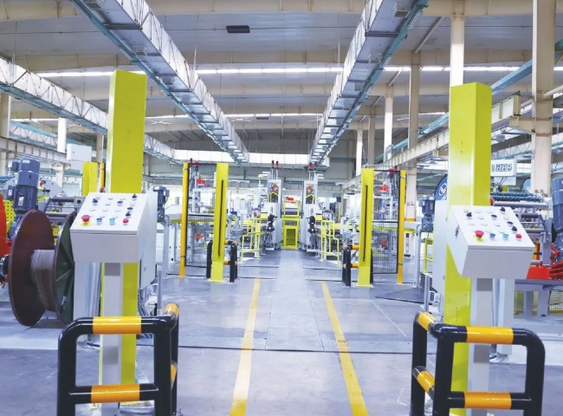
XITE supplied a PSA nitrogen generator plant to a leading HVAC equipment company in the UAE. Our client in Sharjah (UAE) is a manufacturer of air conditioning systems， chillers and refrigeration coils. They need nitrogen for process purification and also for high pressure testing of coils.
The customer has purchased the following specifications of nitrogen equipment from XITE
Technology: Pressure Swing Adsorption (PSA)
Capacity: 300 m3/h
Purity: 99.95%.
The supply of this complete nitrogen plant was done on a turnkey project basis， including the supply of air compressors also within our scope.
Application.
Part of the produced nitrogen will be used at low pressure for the purging of the coils. The remaining nitrogen will be boosted to high pressure by a booster compressor and used for pressure testing of the coils. In fact， we were able to achieve a significant cost savings for the customer by resupplying their existing high pressure air compressor for nitrogen boosting purposes.
A similar case.
Over the past 5 years， as refrigeration manufacturers have become more aware of quality improvements and better quality assurance measures， they have adopted the practice of nitrogen purging and pressure testing to achieve superior performance and results.
We have supplied 3 similar nitrogen generators to the largest air conditioning manufacturer in Saudi Arabia for pressure testing and purging of refrigeration coils. For similar applications， we have supplied a number of nitrogen generators in China. Please ask our sales team for a list of our experience in this industry and we are sure you will benefit from a similar system and enjoy the many benefits highlighted below.
About PSA Nitrogen Generators
For customers using nitrogen via cylinders， PSA nitrogen generators offer many benefits， including a significant reduction in the cost of nitrogen.PSA nitrogen generators are low maintenance and allow for 24×7 operation and peace of mind.PSA is a very mature technology and XITE is the largest manufacturer of PSA nitrogen generators in China， supplying over 1，200 nitrogen generators worldwide.

