Can I use a pressure gauge for nitrogen cylinders instead of a nitrogen pressure gauge?

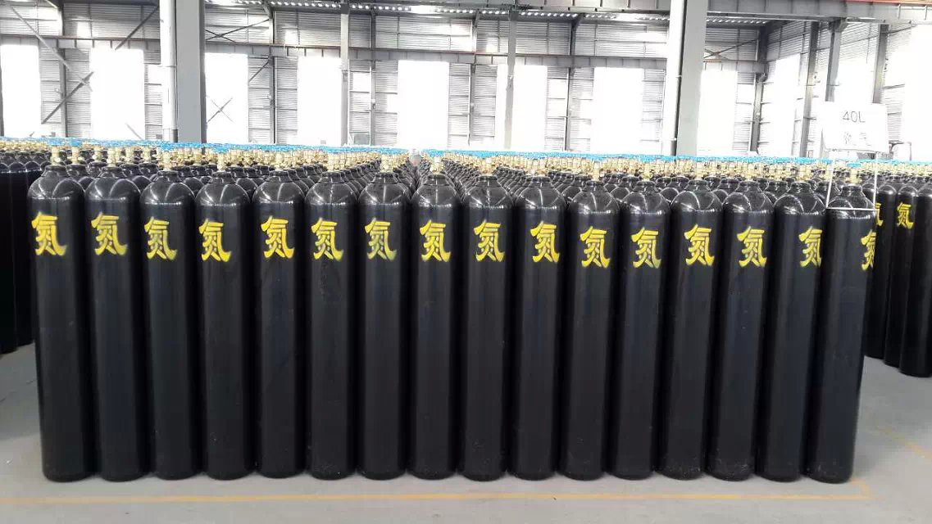
Can， because nitrogen is non-toxic， in the absence of professional nitrogen pressure gauge， you can use pressure change instead.
According to the various industrial sectors in the production process of different media measurement requirements， according to the national standard design and production of special material pressure gauge， specific contains oxygen pressure gauge， acetylene pressure gauge， propane pressure gauge， carbon dioxide pressure gauge， nitrogen pressure gauge， argon pressure gauge， hydrogen pressure gauge and so on.
Pressure gauge refers to the elastic element as the sensitive element， measuring and indicating higher than the ambient pressure of the instrument， the application is extremely common， it is almost all over the industrial process and scientific research field. In the heat pipe network， oil and gas transmission， water supply and gas supply system， vehicle maintenance workshop and other fields can be found everywhere. Especially in the industrial process control and technical measurement process， due to the mechanical pressure gauge of the elastic sensitive element has a high mechanical strength as well as production convenience and other characteristics， so that the mechanical pressure gauge to get more and more most applications.

