Oxygen generators for water treatment and drinking water ozonation

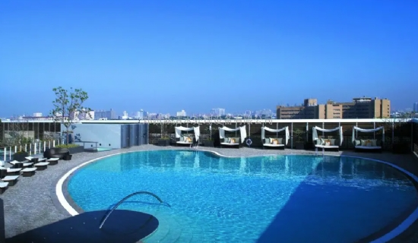

Ozone helps remove chemical elements， such as iron or manganese， from untreated water， as well as organic matter and bacteria. The oxygen needed for this is produced by special oxygen generators.

Water is probably the most important asset. However， untreated water is often contaminated with various substances and must be treated before it can be used as water treatment for industry or as drinking water. A common application for drinking water treatment involves the oxidation of untreated water with high iron and manganese content. Iron and manganese are often found in deep groundwater with low oxygen content. According to drinking water regulations， the limits for iron (0.2 mg/l) and manganese (0.05 mg/l) must not be exceeded， as very high amounts can negatively affect people's health and cause technical damage to the system components and piping systems of water supply companies.

Environmentally friendly treatment
The use of ozone， the so-called ozone treatment， enables a sustainable and almost natural removal of these iron and manganese compounds from water. Ozone is a strong oxidizing agent that， when added to water， oxidizes these compounds to iron hydroxide and manganese dioxide. The oxidized material is poorly soluble and separates at the surface of the multi-layer filter. When it comes in contact with water-borne contaminants， ozone decomposes into atomic oxygen (O)， which causes a strong oxidizing or disinfecting effect， and molecular oxygen (O2)， which increases the amount of oxygen in the water. Viruses and bacteria， which are also often found in untreated water， are also killed by ozone in this way.
As a specialist in the field of water treatment， XITE offers a wide range of ozonation processes and corresponding systems for drinking water and water treatment production. These systems and processes are precisely adapted to the customer's needs and include filtration systems as well as the necessary ozone and oxygen generation equipment. In the different stages of the process， such as flocculation， oxidation， filtration and biomineralization， untreated water is removed of iron， manganese and bacteria， as well as arsenic， hydrogen sulfide， ammonia and nitrates. The enhanced ozonation method even allows the removal of long-lasting chemicals such as organochlorine substances or crop protection and pesticides， as well as the treatment of water containing large amounts of humic substances， which are produced during the transformation of dead organic matter. The advantage of the ozonation method lies in its high oxidation and disinfection effect and， above all， in its high environmental compatibility. Thus， compounds decomposed by ozone are biologically degradable. Ozone itself also decomposes after the decomposition reaction and， if not used， decomposes into O2
Oxygen from ambient air
Ozone is produced with the help of an ozone generator in the ozonated water treatment system at Heroin. Oxygen with a purity of more than 90% is used as process gas. The oxygen required for the process is generated with the help of a XITE oxygen generator. For this purpose， ambient air enters the valve block of the oxygen generator at the required pressure. From there， the air automatically arrives in two alternating adsorption vessels. These vessels are filled with zeolite molecular sieves and are switched in turn from filtration mode to regeneration mode. In this way， the nitrogen and carbon dioxide molecules contained in the air are adsorbed by the molecular sieve in one vessel， while the molecular sieve in the second vessel is regenerated in the presence of compressed air. The oxygen obtained by these methods is passed to a product tank; the filtered nitrogen is discharged to the open air through a duct. This variable pressure adsorption (PSA) method ensures a constant flow of the required volume of oxygen.
The XITE oxygen production plant used by the customer consists of an air compressor (7.5 bar)， a refrigeration dryer for air treatment and an air vessel. Depending on the process and the system， the volume of oxygen supplied by the used XITE oxygen generator varies between 1.1 and 3.5 and 8.1 m3/h. The purity of the oxygen is 92% to 93%. To ensure the necessary fail-safe system， redundant lines for two or more oxygen generators were installed in parallel.

Facts for decision makers
A common application of water treatment is the oxidation of raw water， which has increased iron and manganese content.
The use of ozone， known as ozone treatment， can remove these compounds from water in an environmentally friendly manner.
In order to produce the required ozone， oxygen is necessary and can be obtained directly from the ambient air with the help of a generator.

