Laser Cutting with Nitrogen - Plasma/Laser Cutting Auxiliary Gas

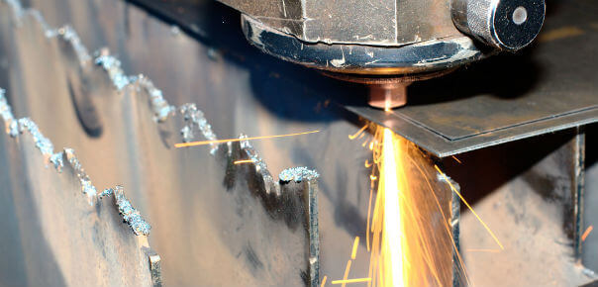
The industrial use of nitrogen covers a wide variety of manufacturing processes. From food and beverage manufacturing to brewing， electronic component manufacturing and applications in oil and gas (oil recovery， tank sealing and gas purification) operations， the use of nitrogen has become indispensable.
Another key industrial application for nitrogen is in laser cutting operations.
In this process， nitrogen helps to prevent oxidation on the cut surfaces of steel， aluminum and titanium sheets， and also helps to purify the laser beam of the application to ensure uniformity of the cutting process. In this article， we will define the process of laser cutting and outline the benefits of applying nitrogen in industrial manufacturing processes.
What is laser cutting?
Laser cutting is an industrial process where a powerful laser beam is used to cut metals such as carbon steel， stainless steel， titanium and aluminum. In most laser cutting processes， a gas stream known as "auxiliary gas" is used to refine the cutting process and make it more efficient. When an auxiliary gas is used for laser cutting， the process is referred to as "gas assisted laser cutting".

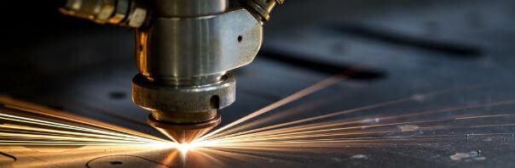
In laser cutting applications， different gases can be used individually or in combination. The most common gases include
Carbon dioxide
Nitrogen
Air
The choice of the auxiliary gas used is determined by various variables such as the material to be cut， the physical properties of the gas type， the ease of procurement and the cost of procuring the required quantity of the auxiliary gas.
Carbon dioxide lasers vs. fiber lasers
Although carbon dioxide lasers and fiber lasers can be used for similar purposes， fiber lasers offer some distinct advantages over carbon dioxide lasers. Fiber lasers offer better safety than CO2 lasers because their beams are more likely to be absorbed rather than reflected. In addition， fiber lasers can cut up to five times faster than conventional CO2 lasers and are relatively inexpensive to operate.
What is plasma cutting?
Plasma cutting is a metal processing technique in which oxygen or nitrogen gas is combined with a high temperature plasma arc to cut metal. The heat generated by this process creates a kerf in the sheet metal by the movement of a high speed plasma stream across the surface of the sheet metal.
Applications of plasma cutting
Although plasma cutting techniques can be used to cut all types of metals， these methods are mostly used to shape medium thickness metal sheets. Plasma cutting with nitrogen can be used to achieve narrow groove cuts with little thermal distortion to the split metal edges.

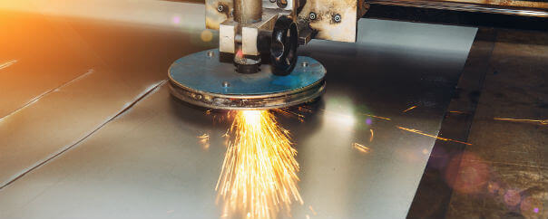
Benefits of Air Assisted Laser Cutting
Air-assisted laser cutting has been in use for over two decades and has some distinct benefits over other cutting technologies.
Return on Investment
The use of air (especially nitrogen) to assist with laser cutting provides a significant return on investment for operators who install them to cut stainless steel. Air-assisted cutting technology will increase the productivity of the associated metal forming process.
Cleaner cutting edges
Air-assisted laser cutting produces uniform metal edges and reduces the deposition of excess material. When a fiber laser is combined with injected air， the cutting surface has less jaggedness than conventional cutting techniques. This is especially important when metal parts are used aesthetically in the final product.
Increased output for fast cutting
Air-assisted laser cutting is a faster method of forming metal materials， especially denser sheets. The increased cutting speed will greatly increase productivity.
Reduced procurement costs
The cost of using air-assisted laser cutting units is significantly lower compared to oxygen and nitrogen. Using ambient air to assist in the laser cutting process will eliminate the need for equipment operators to procure nitrogen and oxygen， thus keeping overall production costs low.
Laser Cutting with Nitrogen
All metal laser cutting operations can be accomplished using nitrogen. This inert gas is ideal for processes involving aluminum and its alloys as well as stainless steel. The operation of a nitrogen-assisted laser cutting machine is simple. The heat of the laser is used to melt the material at a predetermined point， and then a jet of nitrogen is used to remove excess metal from the cut surface.
An important benefit of using nitrogen is that because the gas is inert， there are no additional heat-producing reactions. This allows the operator to achieve a cleaner cut at a faster rate.
Laser beam cleaning
Another application of nitrogen that is directly related to laser cutting procedures is the use of the gas to ensure uniformity of the laser beam over the metal material. Passing a gaseous stream of nitrogen through the laser beam tube eliminates oxygen and any other impurities that could alter the laser's ability to produce a clean， uniform cut.
Prevents Oxidation
Due to the inert nature of nitrogen， using nitrogen in the laser cutting process will reduce the chance of undesirable oxidation occurring on the surface of the metal being cut. Nitrogen will effectively replace oxygen on the metal surface， providing a high quality surface finish and reducing preparation time before welding.
Laser cutting with nitrogen generators (PSA nitrogen generators， nitrogen equipment)
The most practical way to procure the nitrogen needed for laser cutting procedures is an on-site nitrogen generator. Laser nitrogen machines are a cost-effective long-term solution for operators who use the gas to effectively shape sheet metal. Once installed， these machines will deliver nitrogen on demand and eliminate the need for cylinder storage or transportation costs.

