About the construction elements of medical oxygen
Medical oxygen plays an important part in healthcare facilities such as resuscitation and life support. Nursing homes and hospitals require medical oxygen to care for patients at all levels， including surgery， heart failure， trauma， asthma， pneumonia， COVID-19 treatment， and pediatric or maternal care. There has also been a small increase in the demand for medical oxygen in the context of the second wave of coronavirus in China. Health centers treating such patients often use medical oxygen concentrators to provide adequate support for cardiovascular stabilization.

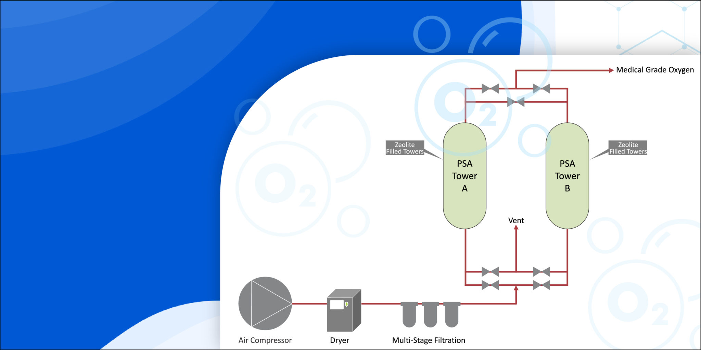

In order to treat patients， medical centers must use pure and clean oxygen. Oxygen for medical use must also be confirmed to meet clinical standards of hygiene and safety. Therefore， reliable oxygen generators must be used to produce high purity oxygen to provide oxygen therapy to patients.
XITEch is one of the large manufacturers， suppliers and exporters of high quality medical oxygen generators， which are a reliable， safe and economical source for producing high purity medical PSA oxygen.
Components of Medical Oxygen
Direct delivery of XITE medical oxygen generators include the following. 1. screw air compressor with refrigeration dryer 2. multi-stage coalescing oil filter for purifying air with oil content below 0.001 ppm 3. air receiver 4. oxygen generator and oxygen analyzer with PLC control 5. oxygen buffer tank 6. microbiological and bacterial filtration equipment
Why is the XITE generator safe?
The XITE Medical Oxygen Generator is automatic and safe to use because it has three safety interlocks.
1. Oxygen purity - The unit has an in-line digital analyzer that measures the purity of the oxygen before the gas enters the buffer tank. If the purity falls below the set value， the supply is stopped and an alarm signal is displayed.
2. Pressure - The pressure of the gas is continuously monitored by a pressure transmitter. If the pressure falls below 3.5 bar， an alarm is issued.
3. Backup System-If the hospital needs backup oxygen， oxygen cylinders can be connected to it.

