Nitrogen generator for cement coal mill with 99.9% purity， 5KG/CM2 working pressure and 90 cfm power

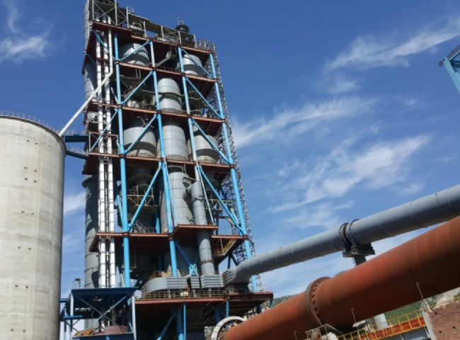
Suzhou XITE has installed a 90 cfm nitrogen generator for the cement coal mill with a purity of 99.9% and an operating pressure of 5 KG/CM2.
Suzhou XITE generates nitrogen on site as a very important step for process safety. The coal mill area is one such location in the cement plant where nitrogen generators are used. Earlier， carbon dioxide cylinders were used to supply inert gas to these units. Carbon dioxide cylinders were scarce and costly. Therefore， since the last 15 years， molecular sieve nitrogen generators have been successfully used in many cement plants to supply inert gas instead of CO2 cylinders. The nitrogen generators have been very successful in replacing the CO2 cylinders used in cement plants. The system being used consists of a nitrogen generator with a high pressure storage tank. The nitrogen is produced by a variable pressure adsorption molecular sieve unit. This nitrogen is stored in a number of storage tanks. In case of any high temperature signal from the mill， bag filter or fine coal bin， this stored nitrogen is dumped into the mill， bag filter or fine coal bin， which will replace the air and keep the fire under control. The stored nitrogen is used for a short period of time. When the nitrogen tank becomes empty， the nitrogen generator restarts nitrogen production and fills the storage tank again by means of a pressure switch on the storage tank. This is a fully automatic system that does not require staff and the nitrogen is available 24 hours a day.
Since nitrogen is a major part of the combustion air， it is also a major part of the exhaust gas. Nitrogen is not a pollutant.
The range of products sold by Suzhou XITE for the oil and gas industry are
MODEL | CAPACITY NM3/HR
GAZ-MS-100 | 90 NM3/HR

