Nitrogen is an important ingredient in food packaging

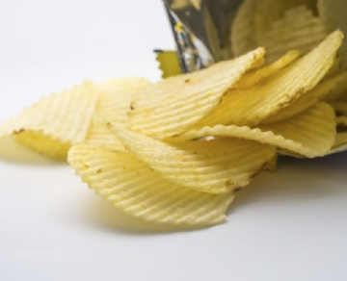
Over time， we have experienced the freshness of packaged food. Its texture， crunchy character and delicious elements can be maintained over time. The reason behind your super-fresh and crisp food packaging is nitrogen. It is the most important gas in the food processing industry.
Oxygen is the culprit gas and it is one of the main causes of spoilage in many food products. The presence of oxygen promotes the growth of bacteria and fungi. The taste of the food changes and the food may spoil. Oxygen is quite active and as such it causes oxidation of food components.
When food is prepared or processed， the presence of oxygen is undeniable. Do not forget that moisture is also part of the atmosphere. What can be done， however， is to fill the packaging with nitrogen to keep your food in a healthy state. Modern food packaging machines have an integrated nitrogen filling port. This nitrogen is filled into the package before the food is added to it. A complete nitrogen environment is provided to the food product， which we also call purification. Nitrogen is a chemically inactive gas which will maintain the characteristics of the food. It helps to maintain the freshness of the food for a longer period of time. Always ensure that even the smallest space is occupied by nitrogen， leaving no room for oxygen or moisture.
Even the dairy industry is now using these on-site nitrogen filling machines. The packaging containing the milk powder is also filled with nitrogen so that no powder spoilage occurs. The milk powder stays fresh and it will give a consistently good taste. Nitrogen purification in milk powder packages ensures that these packages can stay on the shelf for longer and that the contents remain fresh even after a long period of time has passed since they were consumed.
If you are in the food packaging business， you should get in touch with Suzhou XITE in China. We are one of the leading manufacturers of nitrogen via the PSA method. Our team of experts can guide you regarding your nitrogen requirements. We understand that different companies require different sizes of packaging. Therefore， we offer you the right size of nitrogen generator machine to meet your needs. Food that stays on the shelf obviously requires more nitrogen filling than food that is stored in a refrigerator.
The food industry is judged primarily by the type of food they provide. Any form of food spoilage can give a company a bad name and can cause health problems for those who consume these foods. Therefore， nitrogen sparging is important in packaging. Please contact us to find out more about nitrogen and its benefits.
In your hands you are holding a fresh and crisp wafer packet. Yes， the filled air packs may have a few pieces， but you can rest assured that they are fresh and in an edible condition.
Translated with www.DeepL.com/Translator (free version)

