The importance of nitrogen in the food industry

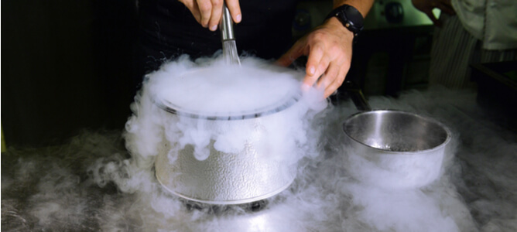
Nitrogen is an important natural resource used in a variety of commercial and industrial applications， including food and beverage manufacturing. Packaging food products with nitrogen has proven to be an effective way of extending their shelf life. In this article， we will discuss nitrogen food preservation methods and the benefits of nitrogen generators for food products.
The impact of nitrogen on the food and beverage industry
The use of nitrogen in commercial food and beverage manufacturing has revolutionised food preservation. Due to its inert chemical properties， gaseous nitrogen slows down the oxidation process that leads to food spoilage.
As a result of packaging food with gaseous nitrogen the shelf life is extended， waste is limited and cost savings are made for retailers. Shop owners can display items that stay fresher for longer， while the end consumer can store and consume their products long after purchase.
Common uses of nitrogen in food industry production
Nitrogen can be used in a variety of manufacturing industries for different applications. Some of the widely used applications of gaseous nitrogen in commercial food and beverage production are outlined below.
Food processing
Food processing is a good example of the use of nitrogen in food industry production. A technique called aeration can be used to create food products with special textures and consistencies. For example， aerated chocolate bars can be created by mixing chocolate with pressurised nitrogen to create a unique micro-aeration effect.
Food packaging and storage
Final packaging is vital in commercial food production as improper packaging can lead to contamination， rapid oxidation and a reduction in the life of the item. The use of food grade nitrogen generators to inject the inert gas nitrogen into the final food packaging will increase the shelf life of the packaged food.

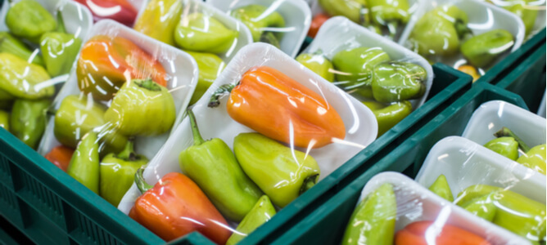
Modified Atmosphere Packaging (MAP)， the replacement of oxygen in packaged food with nitrogen， is a good example of the effects of processing food with nitrogen. In addition to longer shelf life， other benefits of MAP include preservation of freshness， aroma， taste and flavour.
Beverage processing
Beverage production is another area where the use of nitrogen can be beneficial. For alcoholic beverages， gaseous nitrogen can be used to carefully regulate the fermentation process， resulting in high quality wines and beers with good aromas and flavours.
In addition， some non-alcoholic beverages made from fruit and vegetables are subjected to fine conditioning with high purity nitrogen over modified atmosphere packaging (MAP)， where the oxygen in the packaged food is replaced with nitrogen， is a good example of the effects of processing food with nitrogen. In addition to longer shelf life， other benefits of MAP include preservation of freshness， aroma， taste and flavour.
Beverages plus engineering. In these applications， industrial grade nitrogen with a purity of 99% or higher is typically used.
What are the benefits of on-site nitrogen production for the food and beverage industry?
The useful quantities of nitrogen required for food and beverage production can be sourced from cylinders supplied by suppliers or generated on site at the production site.
While both methods of gas procurement can provide the necessary quantities of gas， on-site nitrogen production has some significant benefits.
Access to reliable nitrogen production technology
Industrial operators who choose on-site nitrogen production can benefit from efficient nitrogen production technologies， including PSA and membrane nitrogen generators. These technologies guarantee the production of consistently high purity nitrogen at all times， without the risk of production delays often caused by supply chain disruptions to the gas provided by suppliers.

Improved overall industrial safety
With an on-site nitrogen generator， there is no need to store large quantities of gas for future use， as the required quantities are only generated when needed. Therefore， the industrial safety risks associated with nitrogen storage are completely avoided.
Space saving in industrial sites
The use of food-grade nitrogen generators， rather than supplier-supplied gas， will enable operators to make significant savings in space on industrial floors that would otherwise be occupied by bulky cylinders. In addition， the vital floor space freed up can be used to house other equipment vital to the production process.
Reduced long-term operating costs
After the initial purchase and installation costs， on-site nitrogen generators for food and beverage production are more cost effective than supplier supplied cylinders. In the long term， operators who integrate nitrogen generators into their processes will notice significant savings compared to obtaining gas from suppliers.

