Nitrogen generator for mining (nitrogen generator)

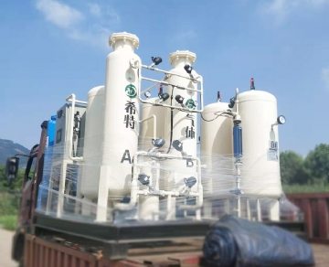
A large amount of nitrogen is very important for the extraction process of nickel. Without nitrogen， the nickel mining process may stop production.
How to use nitrogen in nickel mining
When extracting raw materials from nickel ore， the raw materials will enter the processing plant "as is". In processing facilities， nickel is separated from raw materials and used for further processing. Nitrogen is a key part of this process; Without a large amount of nitrogen， the nickel extraction process will inevitably stop.
Why is on-site nitrogen critical to mining in Africa
Nickel mines in Africa are often located in very desolate or remote places， so the use of liquid nitrogen is almost impossible or at least extremely expensive. Moreover， due to having to rely on liquid nitrogen transportation， mines are often unable to continue the supply required by the nickel extraction process. If the mine is required to be closed due to lack of nitrogen supply， depending on the size of the mine， it may cause a loss of income of more than US $1000000 per day.
On the contrary， with on-site nitrogen membrane generator， nickel mines in Africa can continuously supply nitrogen. They will not be closed because of bad weather or other delays in delivery trucks. On site nitrogen is the only way for the mine to obtain reliable and stable nitrogen supply， so as to keep the mine running with maximum efficiency.
Why use the nitrogen generator of the field gas system
Our nitrogen generator is famous all over the world for providing reliable nitrogen supply to mines. Our on-site nitrogen system can be used for long-term and short-term use， and can also be rented or purchased. They can produce nitrogen with purity up to 99.9% and volume up to 6000 scfm. For our nitrogen generator， we can provide sales and support services far away.

