Where should nitrogen generators be installed and how to ensure safety?

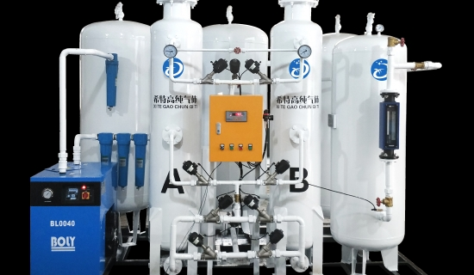
Nitrogen generators are used in a wide range of industries to provide a consistent 99.5% purity of commercially sterile nitrogen from compressed air storage tanks. For any industrial process， nitrogen generators are considered more suitable than nitrogen cylinders because the on-site equipment is more compact， reliable， and easy to use and install. However， the use of these generators is not without any risk.
In this blog， we will tell you about the industries where the generators are installed and the safety measures that you must keep in mind when using nitrogen generators at your premises.
Where to install a nitrogen generator?
Nitrogen generators are used in a range of industries because they help manufacturers meet their end use and can be easily installed in different commercial environments. These generators are used in food packaging processes in industries such as food processing and packaging， in automotive plants for paint booths， in brewing operations for dosing and blending wort， in engineering facilities where N2 is used for manufacturing， testing and product development， and in several other industries where it is used for testing and cleaning tanks and containers.
The on-site nitrogen generator provides an uninterrupted supply of nitrogen at a lower cost than using nitrogen cylinders. It also takes up less space， unlike cylinders， which take up all the floor space. Unlike cylinders， the generator is easy to install and simple to use. Therefore， many manufacturers are choosing gas generators instead of cylinders.
Nitrogen is a colorless， odorless gas that creates an oxygen-deficient area. If the generator leaks gas， it is difficult for people to detect it. In a short period of time， leaking nitrogen can deplete the work space of oxygen， causing harmful effects on the health of employees. However， one can use an oxygen monitor along with the nitrogen generator， which will alert the staff of low oxygen levels.
Use of Nitrogen Generators Safety Measures
1. Leaks - During installation and service， ensure that the system's pressure vessels， pipework， connections and equipment are completely gas-tight.
2. Safety valves - In some cases， safety valves are installed in the pressure vessel and in external locations. Threaded outlets make it easier to connect piping work for this purpose.
Adequate Ventilation - Ensure that there is adequate ventilation and that there is a well-positioned vessel ventilation stream to ensure that oxygen depletion does not occur. Alternatively， you can secure a suitable hose with the correct pressure rating to the vessel drain connection and drain to a safe place.
4. Labels and warnings Warning labels must be prominently displayed on equipment， containers， pipework and plant rooms to inform staff of the presence of nitrogen. This should be done on all equipment， containers and pipework so that it can be clearly read from all directions. As a result， staff can avoid the risk of connections being contaminated or potentially harmful.

