China oxygen equipment and nitrogen equipment manufacturer

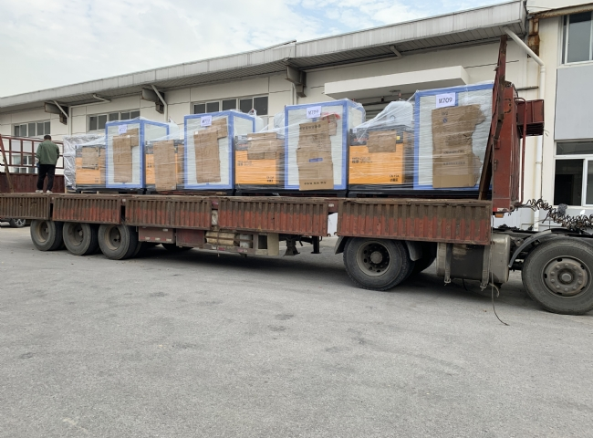
There are many oxygen and nitrogen equipment manufacturers in China， however， Suzhou Schieter in China stands out in terms of standards and quality. Oxygen and nitrogen are produced by these equipment and machines.
According to a survey， oxygen is one of the most sold chemicals on the planet. The high demand for this gas has led to a high demand for oxygen equipment manufacturers and suppliers. However， safety and quality are the key things that distinguish Suzhou Schieter in China from other companies.
Oxygen needs to be separated from other gases using PSA technology. This variable pressure adsorption technology separates and obtains oxygen as it exists in nature. Well， when it comes to nitrogen， we follow a similar process using PSA nitrogen generators.
These devices separate nitrogen and oxygen from the air and are therefore sometimes referred to as air separation devices. Once these gases are separated， you are guaranteed to get the purest gas possible. China Suzhou Schieter is one of the best suppliers of air separation equipment in China and is always concerned about the quality of the gas you get.
Liquid gases are obtained as the final product when the air is compressed at low pressure before starting the separation process. Therefore， they are sometimes also called liquid nitrogen and oxygen generators at low pressure.
Features of our products
As professionals， our equipment offers a variety of features， among others.
- Low operating costs
- Innovative design
- International technology
- Low maintenance costs
- Easy to operate
- Durability， reliability， stability and user-friendliness

