How nitrogen is made and its applications

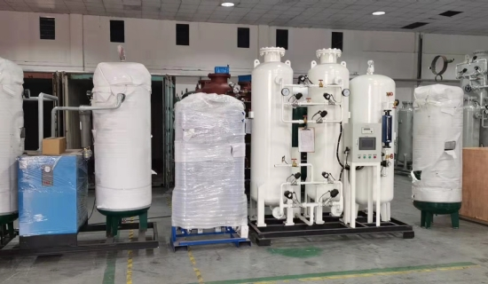
Nitrogen is abundant in the Earth's atmosphere， making up about 78% of the atmosphere. Due to its wide range of industrial applications， nitrogen is also known as a specialized industrial gas. Nitrogen and liquid nitrogen are used in a wide range of applications， including inerting， heat treatment， reactor cooling， freezing， refrigeration， flour and dough cooling， meat mixing， modified atmosphere packaging， etc. Liquid nitrogen is produced in a cryogenic nitrogen generator by extracting air from the atmosphere， which is compressed and cooled to low temperatures in a heat exchanger. The compressed air is then moved into a molecular sieve， where impurities such as carbon dioxide， moisture and hydrocarbons are avoided. Here， the air is moved into a high-pressure distillation column， where nitrogen is separated from the other gases and formed at the bottom of the distillation column. It is distilled without interruption until it meets industrial and medical specifications.
Applications of liquid nitrogen:-
Chemical industry-
Inerting
Nitrogen stripping and recovery
Reactor cooling
Food and beverage
Refrigeration and cooling
Flour and dough cooling
Meat mixing
Modified Atmosphere Packaging
Health Care Industry -
Medical laboratories
Minimally invasive cryotherapy
Tissue transport and platelet preservation
Pharmaceutical and biotechnology
Reactor cooling
Freeze-drying
High quality materials are used to manufacture cryogenic nitrogen devices. Manufacturing is done using the best available cryogenic technology. Materials used for fabrication should be able to withstand high temperatures and pressures and must meet American Society of Mechanical Engineers (ASME) standards. Nitrogen has most applications in both gaseous and liquid forms， but it is primarily stored in liquid form because it is easy to transport and store. Also， liquids are less likely to leak， in addition to being economical. High quality standards must be observed in the manufacture of plant machinery.

