Understanding the different types of compressed air dryers

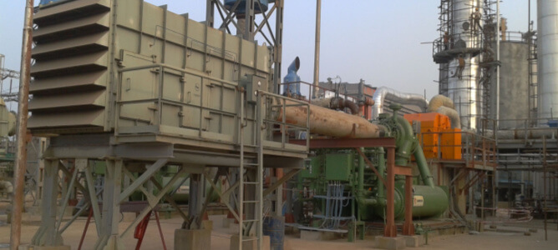
Compressed air dryers are vital to a number of industrial manufacturing processes. Food and beverage manufacturing， compound synthesis， pharmaceuticals and oil and gas exploration are just a few of the industries that require dry compressed air for optimum productivity. This article will further describe the different types of air dryers that can be used.
What is a compressed air dryer?
A compressed air dryer is a piece of equipment that removes water vapour from air that has been pressurised for various industrial purposes. Compressed air dryers are almost indispensable in many moisture-sensitive applications. How do air dryers work? Air dryers are available in a variety of configurations and operate in different ways.
Types of compressed air dryers
The following is a description of the most commonly used air dryer systems.
Refrigerated air dryers
Dehydrated Air Dryers
Desiccant Air Dryers
Chemical Air Dryers
Membrane Air Dryers
Refrigerated Air Dryers
These dryers operate on the principle of condensation. The refrigerated air dryer cools the compressed air to a very low temperature， causing the water suspended in the air to condense into liquid form. Once the water has been removed， the dry air stream can continue to flow to the application that requires it.
There are two types of freeze dryers， recirculating and non-circulating. Circulating freeze dryers operate similarly to a standard refrigerator， providing variable cooling based on demand. Non-circulating units provide constant cooling independent of demand， but this makes them a less efficient option.
Applications
Freeze air dryers are a popular choice for a number of manufacturing and service applications where the absence of detectable moisture in the compressed air is required. However， they are not suitable for highly sensitive applications where even small amounts of water can cause damage.
Advantages and disadvantages
The advantages of refrigerated air dryers include
Low installation costs
Low operating costs
Resistant to airborne particles
Disadvantages include
Not suitable for operation at sub-zero temperatures
Has marginal dew point capability

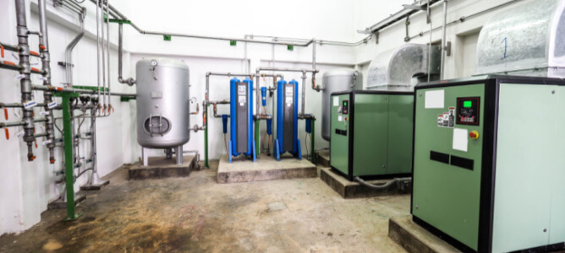
Dehydrated Air Dryers
These dryers have an absorption mechanism that helps to remove moisture from the air passing through them. In addition， degassing dryers use hygroscopic salt flakes which need to be replaced when saturated.
Applications
Degassing dryers can be effectively deployed in hazardous， remote areas where dry， pressurised air is required. Examples of applications that benefit from degassing dryers include landfills， wood and asphalt manufacturing industries.
Advantages and disadvantages
Key benefits of using a tidal dryer include
It is easy to use in special conditions where contaminated air/exhaust gases are handled
Minimal maintenance requirements
No electricity required to operate
The disadvantages of tidal air dryers are as follows.
hygroscopic drying material must be replaced regularly， resulting in increased maintenance costs
Dew point varies with air temperature
Desiccant air dryers
Desiccant air dryers also use hygroscopic materials (silica gel， activated alumina) to achieve air drying. Absorbent units usually consist of a two-tower drying system with both chambers filled with desiccant material.
During operation， one tower is actively drying the air passing through it， while the second tower is in a regenerative state (the desiccant saturated with moisture is being renewed for further use). Throughout the operating cycle， the two towers switch back and forth between the drying and regeneration phases.
Applications
These types of compressed air dryers offer advantages in industrial and commercial applications that are sensitive to moisture， including
Mould and mildew control
Healthcare/medical prescription environments
Food processing
Fabric manufacturing
Ice rinks
Advantages and disadvantages
Advantages of adsorption dryers include
Stable， low dew point
Moderate running costs
Suitable for use in harsh， isolated environments
Disadvantages of using a dryer include
Higher set-up costs
Air filtration required to prevent degradation of desiccant due to suspended oil
Often requires air cleaning
Chemical air dryers
These desiccators utilise hygroscopic materials to achieve the removal of moisture from pressurised air. A typical set-up is a drying unit containing calcium chloride or lithium beads， which pulls moisture out of the air stream passing through it. In addition， high quality coalescing filters and particulate filters are often integrated to extend the life of the drying material.
Applications
Chemical dryers are a good choice for integrating moisture-sensitive chemical manufacturing and food processing applications.
Advantages and disadvantages
Advantages of chemical air dryers include
Low set-up/ongoing costs
Minimal maintenance as there are no moving parts
Little monitoring required
Disadvantages include
High cost of desiccant replacement
High quality filtration systems are required to maintain the effectiveness of the moisture absorbing material
Handling of chemicals is complex and costly
Membrane Air Dryers
Membrane dryers are an effective option for compressed air drying. They use special membranes containing microtubes to filter moisture from compressed air. These microtubes retain the moisture while allowing the dried air stream to flow to the collection unit or desired application.
Applications
Membrane dryers are used in applications where dehumidification， food processing and gas separation are required.
Advantages and disadvantages
The benefits of using these types of air dryers include
Remote operation， no electricity required
Quiet operation with no moving parts
Easy to maintain
Disadvantages of membrane air drying systems include.
Effective operation only in clean air free of oil and particulate impurities
Filters need to be changed regularly to prevent clogging of the filter channels

