Filling of tanks with nitrogen gas

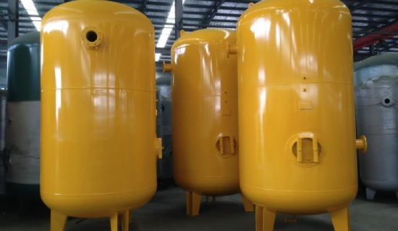
Filling of storage tanks with nitrogen is a very relevant topic because industrial nitrogen is the most commonly used inert gas. Other possible and frequently used gases are: carbon dioxide or inert gases， such as argon. Nitrogen is used as an inert gas to fill tanks to replace the existing oxygen and thus prevent， among other things， unwanted oxidation. Although industrial nitrogen is cheaper than argon， it is still an expensive material overall. Therefore， the pressure range as well as the continuous regulation of the gas are important parameters in any reservoir with a fixed tank top. Tanks with floating tank tops have different requirements.
Excessive pressure in the tank can cause expensive inert gases to be evacuated and then escape to the atmosphere， as pressure compensation is necessary. As a result， small amounts of expensive gas are constantly evaporating. Incidentally， pressure gauge connections in valves can also lead to inadvertent evaporation of expensive gases.
If this happens frequently or continuously， even very small amounts of evaporation can have a negative effect. After all， the cost of 50 liters of industrial nitrogen is on average 35-45 euros. Even those who own nitrogen generators do not want to waste expensive gas and release it into the environment.
By using pressure control valves， which control the pressure of the inert gas in the tank within a well-defined framework， many tank farms use a simple outlined principle.
Small set pressure ? low nitrogen flow ? less gas loss

