Green hydrogen for industrial application

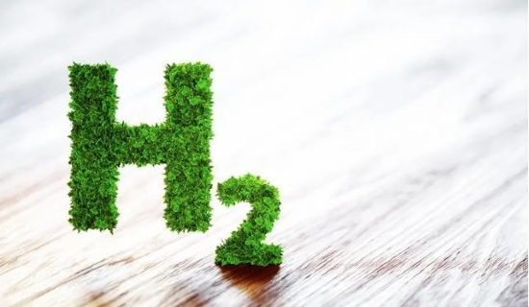
Pure hydrogen has many uses in industry due to its unique physical and chemical properties. Since pure hydrogen does not exist independently in nature， it should be extracted from water or hydrocarbons， the two main sources of this lightest of gases.
XITE supplies an on-site generator for the production of green hydrogen， which its customers can easily use. Water electrolysis is the simplest procedure for producing hydrogen while emitting the least amount of carbon and taking care of the surrounding atmosphere.
Noteworthy aspects of green hydrogen production
Green hydrogen fuel is in direct competition with fossil fuels and other shades of hydrogen. Here are some other essential aspects.
Low-cost raw materials
Typically， deionized water is used as a raw material for the electrolytic production of hydrogen. However， some hydrocarbons can also be used for this purpose and can be obtained at very low prices. Electricity is required to run the hydrogen generator， which adds somewhat to the monthly electricity bill， but is still reasonable compared to the use of hydrogen cylinders.
Simple operation method
Water electrolysis is a simple method that requires only the transfer of hydrogen and oxygen molecules by immersing two electrodes in an electrolyte. The decomposition of hydrocarbons is also a simple chemical reaction， for which no complex equipment is required.
Fast gas transfer
The bipolar high pressure technology is used to transfer hydrogen from the generator to the place where this gas is needed via a pipeline. This transfer process is very fast and smooth， without any risk of leakage， which is an additional advantage for the user.
Hydrogen purity
XITE's hydrogen generator produces 99.999% pure hydrogen by neatly avoiding all traces of other gases and moisture. Thus， it can be safely used in industrial production without any interference caused by impurities.

