Where industrial gases can be of great benefit

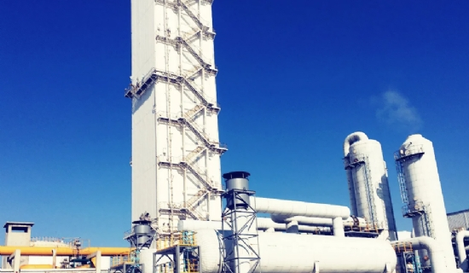
Where industrial gases can be of great benefit
There are many different types of gases， which can be broadly divided into two categories: general industrial gases and specialty gases. General industrial gases are produced and sold in large quantities， but do not require high purity. Although the production and sales volume of special gases are small， there are extremely strict requirements on the purity or composition of different special gases， the maximum allowable content of harmful impurities， and the packaging and storage and transportation of products according to different applications， which are high-tech and high value-added products. Generally， special gases can be divided into three categories， namely， high purity or ultra-high purity gases， standard calibration gases and gas mixtures with specific compositions. As an important basic raw material of modern industry， gas products are widely used in metallurgy， steel， petroleum， chemical industry， machinery， electronics， glass， ceramics， building materials， construction， food processing， medicine and medical sectors， where a large number of common gases or special gases are used.
With the rapid development of China's national economy， the application scope of gas products has been expanding， the dosage has been increasing， new products have been launched， the purity has been improved， the market demand has been expanding， and the growth rate of output value has far exceeded the growth rate of the national economic value in the same period， reaching an annual growth rate of 12%. The annual sales volume of the national gas market is about 40 billion yuan. Although the total output value of the gas industry does not account for a large proportion of the national economy， it has a significant impact on the rapidly developing high-tech sectors such as microelectronics， aerospace， bioengineering， new materials， precision metallurgy and environmental science， and is an indispensable raw material gas or process gas for these sectors. It is due to the needs and promotion of various new industrial sectors and modern science and technology that the gas industry products have made remarkable leaps and bounds in terms of variety， quality and quantity.

