用于石Nitrogen generators for oil pipeline pre-commissioning油管道预调试的氮气发生器

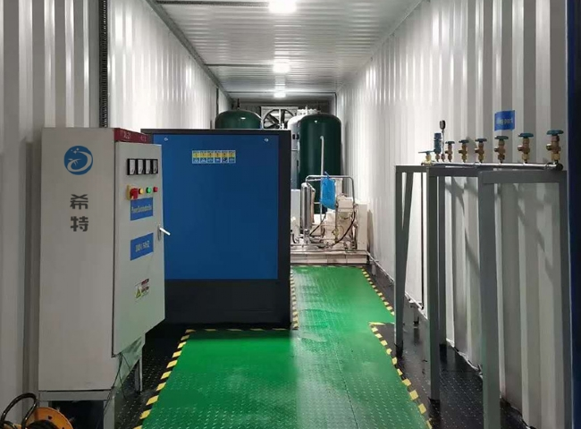
XITE is a large supplier of mobile - containerized - nitrogen generators (pictured) for the oil and gas industry.
Nitrogen is widely used for pre-commissioning and commissioning activities such as nitrogen loading of oil and gas field pipelines， nitrogen purging， nitrogen drying and nitrogen pressure testing.
On-site production of nitrogen inert gas is very economical in onshore and offshore applications.
XITE has supplied many PSA nitrogen generators for such applications to companies in the Middle East， Africa and China.

