Oxygen generators for the chemical industry

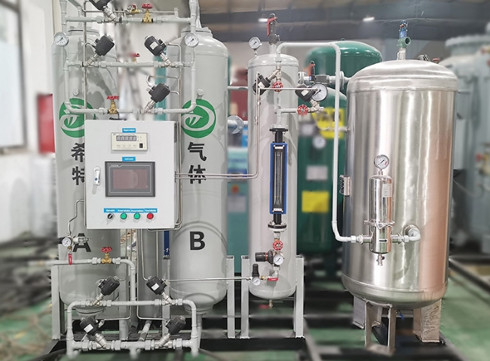
Oxygen is used in the production of nitric acid， sulfuric acid， other compounds and acids in various chemical industries. In its most active form， ozone， oxygen is used in different chemical reactions to increase the reaction rate and ensure the fullest possible oxidation of compounds.
XITE is the market leader in the production of on-site oxygen for chemical reactions. We offer you independent and efficient oxygen gas generators in this field. All our generators are designed and tested by trained professionals before they are installed at the customer's premises.
Users of #Sichter generators are not only environmentally conscious and sustainable， but can save up to 80% from the first minute of operation. For more information， please call us!

