Application of nitrogen in Nanotechnology

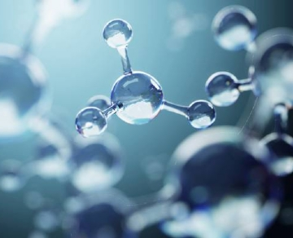
The environment is crucial in handling and manipulating individual molecules and atoms. The components used in nanotechnology must be kept in dry and stable conditions during manufacturing， experiment and storage. With nitrogen， the environment can be easily maintained. Here are some ways that the nanotechnology industry uses nitrogen every day.
How nitrogen helps the nanotechnology industry
The use of literal molecules requires extreme precision. As a result， nitrogen is used in many ways throughout the industry to ensure that everything remains dry and safe.
Drying oven - when key components are stored in boxes， their environment must be maintained so that atoms do not degrade. To ensure that the atoms remain intact when needed， nitrogen is injected into the box. It does not react with the material used and ensures that there are no water damaging molecules.
Chemical inertness - oxygen has potentially dangerous reactions with many chemicals. Therefore， nitrogen is used to replace oxygen in chemical storage or process tanks. It will ensure that the environment does not become dangerous. Nitrogen is also used for inert vessels for the same reason.
Semiconductors - it is important to keep away from oxygen when making stacked chips， rework， or component solder bumps. Nitrogen is used to cover the components so that they have a longer anaerobic treatment window. Due to the problem of chemical aggressiveness， this is particularly important for the new requirements of lead-free welding. With nitrogen inerting， the success rate is much higher， especially when the delta T temperature window works.
MEMS (micro electro mechanical system) - in MEMS applications， high purity nitrogen is required to reduce dross in welding applications. In addition， it effectively reduces the surface tension and cleanly detaches the solder. Nitrogen is also used during the test phase to ensure that the air remains dry.
Line drying - the dew point of nitrogen is as low as -40 ° F， making it an ideal solution for line drying. It is not only not easy to dewing， but also completely inert. It eliminates all oxygen， so there is no risk of oxidation and ensures no explosion.

