Green steelmaking industry
Green Steelmaking
Since the Industrial Revolution， the Earth's average annual temperature is rising. This is mainly due to the burning of fossil fuels which increases the carbon dioxide (CO2) emissions in the atmosphere. Before the industrial revolution， 280 ppm (0.028 %) of the atmosphere consisted of CO2， while at the beginning of 2019， this number has increased to approximately 413 ppm (0.0413 %). Figure 1 shows the increase in annual global temperature and the concentration of CO2 on Earth over the last 800，000 years. The atmospheric CO2 data were provided by the National Oceanic and Atmospheric Administration (NOAA). Since no direct measurements are available， the corresponding information was obtained from ice cores through the European Project on Ice Cores in Antarctica (EPICA).

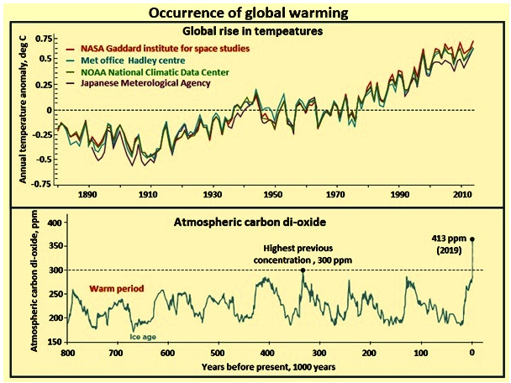
Figure 1 The onset of global warming
Global warming is actually the result of "too much of a good thing". Without the atmosphere， the Earth's surface would be virtually frozen. When sunlight enters the atmosphere， it is absorbed by the oceans and continents， thus warming them. Most of that heat is then radiated back into space as energy-rich infrared light. This is where the "greenhouse gases" come into play. These gases， consisting mainly of water vapor， carbon dioxide and methane， interact with the infrared light so that it does not leave the atmosphere as it enters space. As a result， "good things" happen and the atmosphere retains its heat. It's just that too much of the warming effect has the negative effect of making the atmosphere too warm.
While promoting a clean energy transition， steel is also an important factor in the current challenge the world faces in meeting climate goals. With its heavy reliance on coal and coke as fuels and reducers， the industry's direct CO2 emissions are about 2.6 gigatons per year， or about a quarter of industrial CO2 emissions. In addition， a further 1.1 billion tons of CO2 emissions are caused by the use of its exhaust gases and other fuels to generate electricity and import heat.
The current high dependence on coal for primary steel production， long-term capital assets， and the sector's impact on international trade and competitiveness make the transition to near-zero CO2 emissions challenging. It is for these reasons that the sector is sometimes referred to as one of the "hard to abate" sectors.
Meeting the demand for steel products poses a challenge to the steel sector as it seeks a more sustainable path while remaining competitive. Steel producers therefore have a major responsibility to reduce energy consumption and greenhouse gas emissions， develop more sustainable products， and improve their competitiveness through innovation， low-carbon technology deployment and resource efficiency.
Recent studies estimate that the global steel industry can find that around 14% of its potential value is at risk if steel organizations fail to reduce their environmental impact. Therefore， decarbonization will be a top priority to maintain economic competitiveness and retain the industry's license to operate. In addition， the long investment cycle of 10 to 15 years， the need for billions in financing， and limited supplier capacity make this issue even more relevant and lock in a significant lead time to address the decarbonization challenge.
The steel industry has recognized that long-term solutions are needed to address CO2 emissions from steel production processes. As a result， the steel industry has been very proactive in improving energy consumption and reducing CO2 emissions. Since 1975， energy efficiency improvements have reduced the energy required to produce one ton of crude steel by approximately 50% in most top steel producing countries. Further energy efficiency improvements are being made by expertly maximizing the use of state-of-the-art technology.
Figure 1 shows that since the industrial revolution， atmospheric carbon dioxide levels have risen from 280 ppm to 413 ppm. carbon measurements show that this increase is associated with the burning of fossil fuels (coal， oil and natural gas). Although 1 degree Celsius does not seem high， it is believed that any further increase will have serious consequences， such as the loss of sea ice and the receding of glaciers， leading to a rise in sea level， which is currently measured at an average of 3.3 mm per year. To avoid the adverse effects of climate chances， global warming needs to be kept below 2 degrees Celsius.
In terms of total global fossil and industrial emissions， the steel industry is a specialized single sector， accounting for 7% to 9% of greenhouse gas (GHG) emissions. It is a specialized industrial emission source， currently accounting for about 8% of global final energy demand. As such， it is a primary concern for governments. On the other hand， steel is critical to modern economies and， as such， global demand for steel is expected to grow to meet the growing demand for social and economic welfare. It is also a key input to the clean energy transition. The generation and use of electricity depends in part on the ferromagnetic properties of steel and its alloys. Steel is a key input material for wind turbines， transmission and distribution infrastructure， hydroelectric and nuclear power plants， and other key energy sector assets.
Green steelmaking includes the use of processes that reduce CO2 emissions. Green steelmaking processes are being developed in the EU， US， Canada， bar West， Japan， Korea， Australia and China. For the development of green steelmaking technologies， five key directions are being explored. These directions are (1) technologies involving coal use， (2) technologies involving hydrogen use， (3) technologies involving electrons， (4) technologies involving biomass use， and (5) technologies involving carbon capture， use， and/or storage (CCUS). Figure 2 shows the pathway to breakthrough technologies for reducing CO2 emissions from ore-based steel production routes.

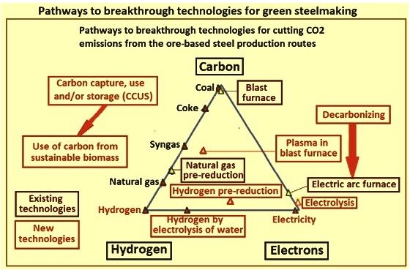
Figure 2 The path to breakthrough technologies for green steelmaking
In the EU， breakthrough technologies are being developed under the ULCOS (Ultra Low CO2 Steelmaking) program. Under this program， the following developments are underway: (i) "top gas circulation blast furnace" (TGR-BF) with carbon dioxide capture， use and/or storage (CCUS); (ii) HIsarna process with CCUS， involving smelting reduction; (iii) ULCORED with CCUS， involving a new direct reduction (DR) concept; and ( (iv) electrolysis. In addition to these， ULCOS is also investigating the use of carbon from sustainable biomass and hydrogen-based steelmaking.
In the United States， development work is underway in a "public-private partnership" between the American Iron and Steel Institute (AISI) and the U.S. Department of Energy (DOE) and the Office of Industrial Technology. Two projects represent important steps forward. These projects are (i) suspended hydrogen reduction of iron oxide concentrates， and (ii) molten oxide electrolysis (MOE). In the near term， AISI members are working on the development of a "paired straight-bore furnace"， a coal-based DRI and molten metal process for long-term replacement of blast furnaces and coke ovens.
In Japan， development work is being conducted under the COURSE50 program involving six steel and engineering organizations， the Japan Iron and Steel Federation and the New Energy and Industrial Technology Development Organization. The research and development objectives of the program are (1) reduction of CO2 emissions from the blast furnace iron ore reduction process with other reducing agents (hydrogen)， (2) modification of coke oven gas with the aim of increasing the hydrogen content by using waste heat， and (3) high strength and highly reactive coke reduced with hydrogen. Development work is also underway to capture CO2 from blast furnace gas， including (i) chemical and physical absorption to capture， separate， and recover CO2， and (ii) use of waste heat from steel mills to reduce energy requirements for capture， separation， and recovery.
In Korea， development work is being conducted with the participation of POSCO， RIST， POSLAB and POSTECH. Three promising routes for breakthrough CO2 solutions have been identified. They are (i) carbon refining of steel， including the carbon refining FINEX process， and pre-reduction and heat recovery of hot sinter ore; (ii) carbon capture and sequestration in steelmaking through the use of ammonia to absorb CO2 and sequestration of CO2 in marine gas fields; and (iii) hydrogen steelmaking through the use of hydrogen-rich syngas to reduce iron ore in the FINEX process， and the hydrogen-rich blast furnace process.
Emerging technologies to reduce or avoid carbon emissions in steelmaking can be divided into two different categories， namely (i) carbon capture， use and/or storage (CCUS)， and (ii) alternative reduction of iron ore.CCUS employs different methods to capture CO It either stores them (e.g.， in geological formations such as depleted subsea gas reservoirs) or treats the emissions for continued use. CCUS alone cannot achieve carbon neutrality. However， if the fossil fuels used in the steelmaking process are replaced by biomass， it can lead to a negative CO2 balance.
A second category of potential technologies involves replacing coke or natural gas with alternative reductants from iron ore. These include hydrogen and direct current. The advantage of these technologies is that they could theoretically make steel production completely green. However， most of them may require more time and money to set up than CCUS.
The most promising new CCUS and alternative reduction technologies， as well as hydrogen-based direct reduction technologies， are discussed below.
Technologies with CCUS
In these technologies， carbon dioxide emitted during operation is separated from other gases and captured. The captured CO2 is then transported or shipped via pipeline to storage sites onshore or offshore， or used.The CCUS process includes post/pre-combustion capture， compression， transport and storage/use. Figure 3 shows a CCUS scenario for a simplified blast furnace-basic oxygen furnace (BF-BOF) steelmaking route.

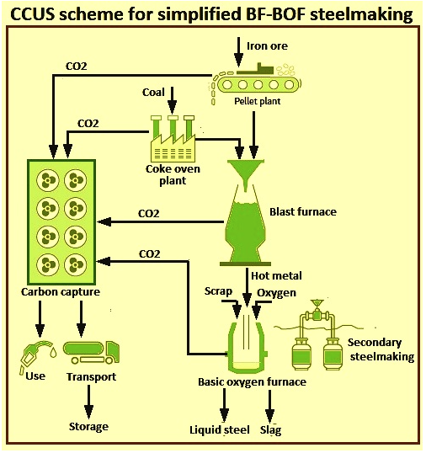
Figure 3 CCUS solution for simplified BF-BOF route
The main advantage is that the CCUS system can be easily integrated into an existing conventional brownfield site plant. And， since the technology is not specific to steelmaking， other industries can share in the development and infrastructure costs. In addition， future operating costs are largely predictable.
The main drawback is that CCUS is not completely carbon neutral， as the carbon capture process alone only captures about 90% of the CO2. In addition， there are a number of other challenges. Public acceptance of carbon storage is uncertain， which puts first movers in a bad position. In addition， the ocean is currently the only suitable location for large scale storage other than small-scale land-based storage sites， which requires significant transportation efforts. In addition， the emissions are utilized to ensure that there are no carbon emissions at a later stage of the process to achieve carbon neutrality. In addition， CCUS equipment adds maintenance burden and downtime， which has a significant impact on operating costs.
There are some pilot projects that have started processing emissions such as CO2 to make synthetic fuels. However， this is not carbon neutral at this time， as CO2 is emitted at a later stage.
Biomass-based ironmaking with CCUS
The basic idea of these technologies is that carbon neutral biomass partially replaces fossil fuels in pretreatment， or as iron ore reductant. Examples are the production of replacement coke from carbon rich "coke" made from virgin biomass (virgin seaweed， grass， wood， etc.) or the injection of biogas into a shaft furnace to replace natural gas. Processes based on these technologies include pyrolysis and hydrothermal carbonization. the CCUS system takes care of any remaining carbon emissions.
Biomass alone can reduce CO2 emissions by 40 to 60 percent， and in combination with CCUS can lead to carbon-neutral steelmaking. In the short term， biomass can immediately partially replace fossil fuels， allowing for rapid results in reducing emissions from existing plants. The emitted CO2 can also be recovered using CCUS to produce new biomass.
However， the cultivation of biomass is difficult. On the environmental side， it can lead to deforestation， pollution and reduction of biodiversity， and on the social side， it affects food prices and the use of agricultural land. Therefore， the risk of political and social acceptance is high. In addition， biomass has a lower calorific value than fossil fuels， limiting its use in large blast furnaces or leading to lower efficiency. It may also be too heavy to be used in large blast furnaces due to its high water content.
A study on the use of biomass at the SSAB steel plant in Lulea， conducted by the Swedish research group SWEREA， found that using biomass for ironmaking could reduce CO2 emissions by 28%.
Hydrogen-based direct iron reduction shaft furnace
In this process， hydrogen replaces a carbon reducing agent (such as reformed natural gas) for the reduction of iron ore pellets to "direct reduced iron" (DRI or sponge iron). The reaction takes place in a shaft furnace. The produced DRI is then fed to an electric arc furnace， where it is turned into steel by further processing through the addition of carbon. DRI can also be fed to the blast furnace as "hot briquetted iron" (HBI). This greatly increases the efficiency of the blast furnace and reduces coke consumption. The most common similar process technologies are the Midrex and Energiron processes.
In hydrogen-based reduction， the iron ore is reduced by a gas-solid reaction， similar to the DRI production path. The only factor that differs is that the reducing agent is pure hydrogen rather than carbon monoxide gas， syngas or coke. The reduction of iron ore by hydrogen takes place in two to three stages. For ores at temperatures above 570 degrees Celsius， hematite (Fe2O3) is first converted to magnetite (Fe3O4)， then to wostite (FexO) and finally to metallic iron， while at temperatures below 570 degrees Celsius， magnetite is converted directly to iron because wostite is thermodynamically unstable.
The reduction reactions involved in the reduction of iron ore by hydrogen are represented by the following equations: (i) 3 Fe2O3 + H2 = 2 Fe3O4 + H2O， (ii) x Fe3O4 + (4x-3)H2 = 3 FexO + (4x-3)H2O， and (iii) FexO + H2 = x Fe + H2O， where x equals 0.95. As these reactions indicate， the reduction of iron ore by hydrogen reduction of iron ore releases harmless water vapor (H2O) instead of the greenhouse gas CO2. the overall reaction for the reduction of hematite with hydrogen is Fe2O3 + 3H2 = 2Fe + 3H2O， which is an endothermic reaction with a heat of reaction delta H at 298 degrees C = 95.8 kJ/mol， which is negative for the energy balance of the process and requires an increase in energy with the injected reducing gas/ gas mixture to increase the energy. The development of the line was focused on the optimization based on reduction temperature， reaction kinetics， pellet composition and reduction gas preheating techniques.
The stoichiometric consumption of hydrogen gas for the reduction of hematite (Fe2O3) is 54 kg per ton of iron. Therefore， a steel plant with a capacity of 1 million tons per year requires a hydrogen plant with a hydrogen capacity of up to 70，000 m3/h at standard temperature and pressure (STP). With hydrogen as reducing gas， it is important to predict changes in the behavior of the reactor compared to a reactor with a hydrogen-carbon monoxide mixture as reducing gas. Several factors can interact in different ways， such as kinetics， thermodynamics， heat transfer and gas transport.
The process makes the entire primary steelmaking route carbon neutral and fossil fuel free if green power is used exclusively in the process. Other advantages of the process are the high production flexibility. The process is easy to start and stop， and the technology's ability to use smaller units allows for greater scalability. In addition， the ability to feed DRI as HBI into the blast furnace-basic oxygen furnace steelmaking system means that existing conventional brown clay plants can be used while the shaft furnace/EAF production is being released.
The process still requires iron ore pellets， and the production of iron ore pellets can result in significant emissions depending on the heat source of the pellet plant. Providing the necessary amount of hydrogen is also an issue and requires the development of efficient large-scale electrolyzers. In addition， since the process relies on large amounts of cheap green energy， if steel producing countries cannot significantly increase their own green energy production， they will have to import hydrogen or pre-processed iron， thus damaging their value chain. There is also uncertainty about future operating costs， which are related to the price of hydrogen and electricity. Figure 4 shows a hydrogen shaft furnace for direct iron reduction.

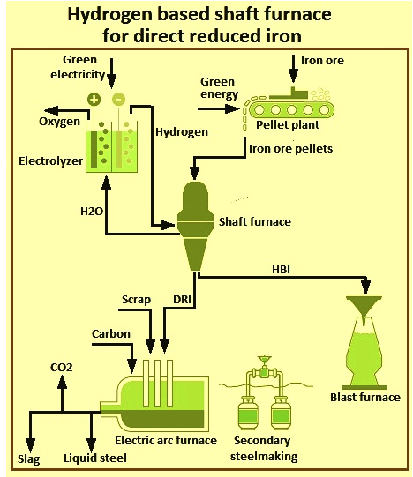
Figure 4 Hydrogen-based shaft furnace for direct reduction of iron
The HYBRIT process uses a hydrogen-based shaft furnace to produce DRI.HYBRIT stands for "HYdrogen BReakthrough Ironmaking Technology".On April 4， 2016， three Swedish companies - SSAB， LKAB and Vattenfall AB - launched a project to investigate the feasibility of an H2-based DRI production process using CO2-free electricity as the primary energy source. A joint venture company， HYBRIT Development AB， was formed with all three companies as owners. This allows full access to top-level capabilities across the value chain， from energy production， mining， ore beneficiation and pellet production， direct reduction， melting and crude steel production.A pre-feasibility study for H2-based direct reduction was conducted in 2017. The study concluded that the proposed process route is technically feasible and economically attractive for the conditions in northern Sweden/Finland， considering future trends in CO2 emissions and electricity costs.
The HYBRIT process uses hydrogen instead of coal for the direct reduction of iron， in combination with an electric arc furnace. The process is almost completely free of fossil fuels and significantly reduces greenhouse gas emissions. The process is one of several initiatives using a hydrogen direct reduction/electric arc furnace setup that will use direct reduction of iron ore with hydrogen in combination with an electric arc furnace for further processing into steel. The product of the hydrogen direct reduction process is DRI or sponge iron， which is fed into the electric arc furnace， mixed with the appropriate percentage of scrap and further processed into steel.
A schematic flow diagram of the HYBRIT production process is shown in Figure 5. The main features of the process are: (i) the use of non-fossil fuels in pellet production; (ii) the production of hydrogen by electrolysis using fossil-free electricity; (iii) the storage of hydrogen in a specially designed facility that acts as a buffer for the grid; (iv) the use of a shaft furnace for iron ore reduction. (v) use of customized pellets as iron ore feedstock， (vi) reduction gas/gas mixture is preheated before injection into the shaft furnace， (vii) the product can be carbon free DRI or HBI or carburized， and (viii) DRI/HBI is melted in an electric arc furnace along with the recovered scrap.

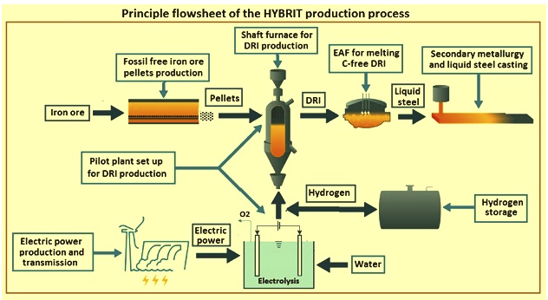
Figure 5 Schematic flow diagram of the HYBRIT production process
The reduction of iron ore pellets in a shaft furnace using hydrogen produced by electrolysis of water with fossil-free electricity is the main option of the HYBRIT initiative. According to this initiative， the conversion of the fossil-free value chain from mine to finished steel includes many issues to be developed， which also take into account local market and geographical conditions. Sweden has a unique situation with excess power capacity in the northern part of the country， proximity to iron ore mines， good access to biomass and steel mills， and a strong network between industry， research institutes and universities.
The HYBRIT process falls into a category of technology concepts that are considerably closer to commercial deployment. It is based on the production of hydrogen by electrolysis based on renewable electricity， using hydrogen as a reducing agent. From an environmental point of view， its most important advantage is that the exhaust gas of the process is water (H2O) rather than CO2， thus reducing greenhouse gas emissions. As with conventional DRI steelmaking， the iron produced using the hydrogen-based DRI route can be further processed into steel using commercially available electric arc furnace technology. Hydrogen production and electric arc furnace steelmaking steps can be carbon-free if electricity and hydrogen are produced from renewable sources， such as photovoltaic (PV) solar/wind/water electrolysis， photochemical hydrogen production， or solar-thermal water separation.
Hydrogen-based fluidized bed process for direct iron reduction
Like the shaft furnace version， this technology uses hydrogen to reduce iron ore and produce direct reduced iron for the electric arc furnace. The difference is that the reduction takes place in a fluidized bed rather than in a furnace and uses finely processed iron ore fines/concentrates rather than pellets. Fluidized beds are reaction chambers that allow uninterrupted mixing of solid feedstock with gas to produce solids. Similar processes include FINEX and Circored.
The advantage of using fines instead of iron pellets is that no pelletizing is required， thus reducing costs and the high CO2 emissions of the process. In addition， fluidized bed reactors have fewer internal sticking problems than shaft furnaces and can achieve higher metallization (about 90 to 95 percent).
The process has the same issues as the shaft furnace method in terms of hydrogen supply， electrolyzer and operating costs. The power supply will also be 100% green to achieve carbon neutrality. In addition， the fluidized bed reactor is not as developed in steelmaking as the shaft furnace and therefore requires more investment. Figure 6 shows the hydrogen-based fluidized bed process for direct iron reduction.

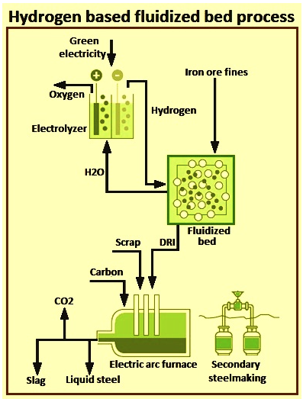
Figure 6 Hydrogen-based direct iron reduction process in fluidized bed
Hydrogen-based concentrate reduction (abbreviated as HYFOR) is the world's first process for the direct reduction of iron concentrates from concentrates without any pretreatment of the material， such as sintering or pelletizing. This reduces the cost of capital expenditure and operating expenses. The process is capable of processing a wide variety of ores， such as hematite and magnetite.
The HYFOR process was developed by Primetals Technologies. This new technology can be applied to all types of beneficiated ores. It has a particle size of less than 0.15 mm for 100% of the raw material， while allowing a specialty particle size of 0.5 mm. Due to the large particle surface， the process achieves high reduction rates at low temperatures and low pressures.
As the main reducing agent， the new process uses hydrogen. The hydrogen can come from renewable energy sources or hydrogen-rich gas from other gas sources， such as natural gas pyrolysis or conventional steam reformers. As an alternative， HYFOR can be operated in hydrogen-rich waste gas. Depending on the source of the hydrogen， this will result in low or even zero CO2 emissions from the resulting DRI.
A pilot plant for testing purposes has been commissioned in April 2021 at voestalpine Stahl Donawitz in Austria. The plant has a modular design with a rated capacity of 250，000 metric tons per year per module， making it suitable for all sizes of steel mills. The purpose of the pilot plant is to provide practical evidence of this breakthrough process and to serve as a test facility to collect enough data to build an industrial-scale plant at a later date.
The first tests have been successfully executed in April 2021 and May 2021. One test was sized in the range of 800 kg of iron ore processed. the HYFOR pilot plant will be operated for at least 2 years in multiple campaigns to test various ore types and to evaluate optimal process parameters for the next scale up. Assuming smooth operation， a hot briquetting plant will be added to verify the hot briquetting step and the desired HBI quality of the HYFOR technology.
The HYFOR process significantly reduces CO2 emissions and helps producers effectively address the challenge of declining iron ore quality， which has recently become more severe， resulting in increased demand for ore beneficiation. The increasing demand for iron ore pellets from blast furnaces and direct reduction plants has led to higher iron ore prices， particularly at a premium for pellets. With the HYFOR process， it is possible to use pellet ore directly and benefit from the rising global supply of ultrafine fines.
The HYFOR pilot plant at voestalpine Donowitz consists of three parts， namely (i) the preheat-oxidation plant， (ii) the gas treatment plant， and (iii) the core part， the new and unique reduction plant. In the preheat-oxidation plant， the concentrate is heated to approximately 900 degrees Celsius and fed to the reduction plant. The reduction gas is 100% hydrogen， supplied by a gas supplier located outside the plant boundary. A waste heat recovery system that obtains heat from the exhaust gas ensures optimal use of energy， while a dry dust removal system takes care of the dust emissions from the process. Hot Direct Reduced Iron (HDRI) leaves the reduction facility at a temperature of approximately 600 degrees Celsius before being cooled and discharged from the HYFOR pilot plant.
Hot Direct Reduced Iron leaving the reduction plant at a temperature of around 600 degrees Celsius can then be transported and fed directly into an electric arc furnace or used to produce hot briquetted iron. The hot briquetted iron is used to supply the market. The next step will be to add a hot briquette test facility to test the properties of the hot briquetted iron.
The purpose of the HYFOR pilot plant is to validate this breakthrough process and to serve as a test facility to provide a data base for scaling up the plant to an industrial scale prototype plant as the next development step.
Suspended Ironmaking
Suspended ironmaking is also known as "flash ironmaking technology". The process begins with ultra-fine grinding of low-grade iron ore to produce iron ore concentrate. The iron ore is ground to particles less than 100 microns in diameter. The ultrafine powder is then reduced in a high temperature "flash" reactor using hydrogen gas， which takes only a few seconds and produces iron directly once carbon is added. The iron concentrate can also be pre-reduced in a separate reactor at a lower temperature before being added to the flash reactor. Figure 7 shows the principle of suspension ironmaking.

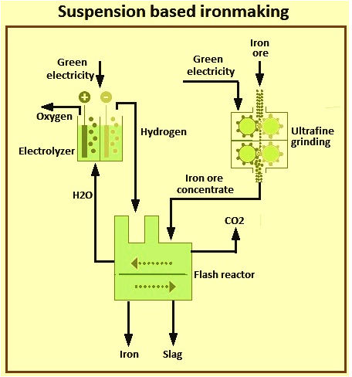
Figure 7 Flash Ironmaking
With funding from the American Iron and Steel Institute， a number of organizations and institutions in the United States are developing a transformational technology for flash ironmaking. This technology is based on the direct gaseous reduction of iron oxide concentrates in a flash reduction process. The technology has the potential to reduce energy consumption by 32% to 57% and CO2 emissions by 61% to 96% compared to the current average BF-based operation. The technology is suitable for industrial operations that convert iron concentrates (less than 100 microns) into steel without further treatment.
This technology bypasses the steps of pelletizing or sintering and coking while producing iron. In addition， because the fine particles of concentrate are rapidly reduced at temperatures ranging from 1，150 degrees Celsius to 1，350 degrees Celsius， the process requires a residence time of a few seconds instead of the minutes or hours required for pellets or even iron ore fines. At 1，200 degrees C to 1，500 degrees C， 90% to 99% reduction is accomplished in 2 to 7 seconds. The energy requirement of the process with H2 as reducing gas is 5.7 GJ (1，360 Mcal) per ton of iron ore.
Direct reduction of iron ore to steel in a single reactor eliminates the need for ironmaking and sintering or pelletizing. It offers considerable cost and emission advantages. It also produces "cleaner" steel due to the high temperatures and fast reaction times that ensure fewer impurities.
Using H2 as reducing gas， the CO2 emissions per ton of liquid iron are 0.04 tons. These emissions are 2.5% of the emissions from the BF ironmaking route. The flash iron process is carried out at a sufficiently high temperature so that the individual particles have enough energy to close the pores created by oxygen removal. As a result， individual particles are far less likely to catch fire from rapid oxidation. Small samples of the powder were studied at the University of Utah and it was determined that they were not pyrophoric.
The process will be applied to the production of iron as a feedstock for the steelmaking process or as part of the uninterrupted direct steelmaking process. Based on the experimental data obtained in the first phase of the project， the University of Utah is currently working on scaling up the development. Testing in a laboratory flash furnace has led to the development of a kinetic database under most operating conditions and the complete design of a more advanced benchtop reactor. A full-scale bench-scale test is planned in order to develop an industrially viable flash iron technology. The results of this phase of the project are expected to be a determination of process scalability， substantial process simulation results， and basic engineering data leading to the design and construction of an industrial pilot plant. A flow chart of the flash ironmaking technology is given in Figure 8.

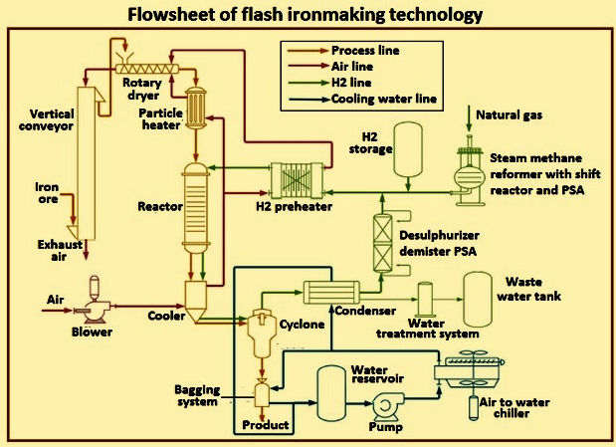
Figure 8 Flow chart of flash ironmaking technology
Plasma direct steelmaking
In the plasma direct steelmaking process， iron ore (in the form of raw ore or fines or pellets) is reduced in a plasma steelmaking reactor using a hydrogen plasma. At the same time， carbon is added to the reactor to produce steel. The hydrogen plasma is heated or charged to separate or ionize the hydrogen into its constituent particles. The process can use either thermal plasma (produced by directly heating the hydrogen) or non-thermal plasma (produced by passing direct current or microwaves through the hydrogen).
The process avoids the need for pretreatment of the iron ore and allows for lower reactor temperatures. It is also highly integrated， with some methods (e.g.， hydrogen plasma smelting reduction) requiring only one step. This makes it commercially attractive. The technology has the potential to significantly reduce costs. It also offers higher product quality and better production flexibility.
The technology is in a very early stage of development， with the optimal process and complete reactor design still to be developed. Its commercial viability also remains to be proven. As part of its Sustainable Steel (SuSteel) project， Austrian steelmaker voestalpine has built a small pilot hydrogen plasma reduction reactor at its Donawitz plant. The process of direct plasma steelmaking is shown in Figure 9.

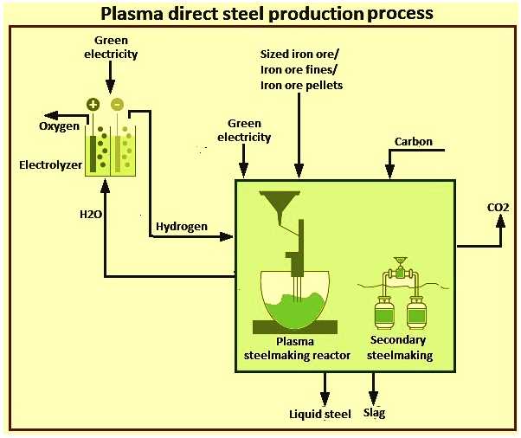
Figure 9 Plasma direct steelmaking process
Electrolysis process
There are two types of electrolytic processes. They are: (i) electrolysis， and (ii) electroforming. Variants of these two processes are referred to as ULCOWIN and ULCOLYSIS in the ULCOS program.The ULCOWIN process operates in an aqueous alkaline solution slightly above 100 degrees C， which is filled with small particles of ore. In this process， the iron ore is ground into an ultrafine concentrate， leached， and then reduced in an electrolyzer at a temperature of approximately 110 degrees Celsius. The resulting iron plates are fed into an electric arc furnace and turned into steel. ulcolysis operates at steelmaking temperatures (about 1550 degrees Celsius) with a molten salt electrolyte made from slag (thermal electrolysis). This process uses electricity as a reducing agent to convert iron ore into liquid steel. Figure 10 shows the electrolysis process for steel production.

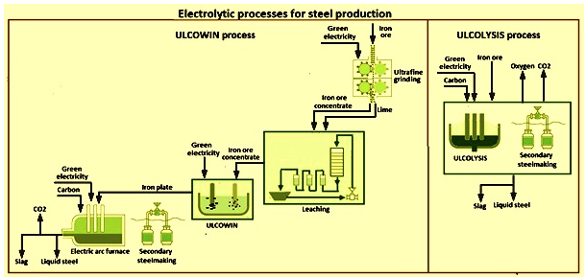
Fig. 10 Electrolysis process for steel production
The electrolysis process was developed from the ground up within the ULCOS program and is therefore still operating at laboratory scale. Although it holds the promise of zero emissions， it will take time to scale it up to commercial scale (10 to 20 years) if green power is available. the ULCOWIN process includes alkaline electrolysis of iron ore. Electrolysis is typically used to produce metals other than steel and requires large amounts of electricity. The process is dependent on clean sources of electricity such as renewable energy， hydroelectric power or nuclear power. ulcolysis is molten oxide electrolysis. Molten oxide electrolysis works by passing an electric current through a molten slag containing iron oxide. The iron oxide decomposes into liquid iron and oxygen. No carbon dioxide is produced. Process emissions are further reduced by the CO2 clean power source.
Since electrolytic processes skip the upstream stages required for other production routes， such as the production of coke or H2 as reducing agent， these processes have the potential to be the most energy-efficient steelmaking technologies， especially electrolysis. They are also expected to significantly reduce capital expenditures since， in the case of electrolysis， only very little equipment is required. The process is also relatively inflexible compared to the direct hydrogen reduction process， as it cannot be easily stopped.

