Application of nitrogen generators in the refrigerant and HVAC industries

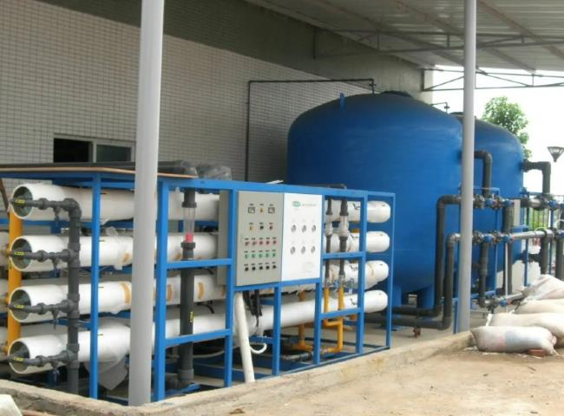
Refrigerants are what make air conditioning possible. These liquid formulations are contained in the coils of air conditioners and cool and dehumidify the room air.
For many years， the most common refrigerant used in air conditioning systems was R-22 (Freon). Today， in response to growing environmental concerns and the depletion of R-22 resources， production of systems using R-22 refrigerant is being phased out and R-410A is increasingly replacing it as the refrigerant gas of choice.
In the coming years， the supply of R-22 is likely to become short. So by choosing an R-410A system now， you can move ahead with an ozone-friendly solution.
Unlike refrigerants containing bromine or chlorine， R-410A is completely chlorine-free and therefore has zero ozone depletion potential (ODP)， making it the most widely used refrigerant of choice for residential and commercial air conditioning in many countries around the world， and sold under trademarked names such as Forane 410A. Puron， EcoFluor R410， Genetron R410A and AZ- 20， a mixture of isotropic but nearly anisotropic difluoromethane (CH2F2， known as R-32) and pentafluoroethane (CHF2CF3， known as R-125)， are used as refrigerants in air conditioning applications.
Air conditioners using R-410A operate at much higher pressures than other refrigerants (R-410A operates at 50-70% higher pressures than R-22). Therefore， a high-pressure test with nitrogen is required before charging the refrigerant to avoid unnecessary refrigerant discharge， and the system should be checked for leaks with pressurized nitrogen before charging.
Since certain concentrations of R-410A become combustible when mixed with air， it is recommended not to mix R-410A with air or oxygen for leak testing or to pressurize the system. Therefore， nitrogen should be used for leak testing or to pressurize the system.
In an R-410A system， only a mixture of nitrogen and R-22 can be used as a leak test gas (trace gas). Also， nitrogen is the gas of choice for use in this process because it does not harm the environment and does not support combustion or oxidation like air or oxygen. r-22-nitrogen leak test gas is not subject to a ban on emissions because ozone-depleting compounds are not used as refrigerants in these cases.
Before adding nitrogen to an R-410A system， the system must be evacuated to 0.0 psig. Otherwise， the R-410A-nitrogen-R-22 mixture will be considered a refrigerant， and its release will violate EPA regulations and be subject to fines.
For the HVAC industry， air conditioning coil testing applications， XITE has offered a number of high pressure nitrogen generators with pressures up to 1000psi (70Bar). This includes turnkey projects for nitrogen generators， including high-pressure booster compressors and storage tanks. The nitrogen in the tanks is used for pressure testing according to the customer's requirements.
PSA nitrogen generator - for purity above 99.9%
PSA nitrogen generators are powerful systems for the production of nitrogen with a purity of 99.9% or higher.PSA is a very mature technology and XITE is a professional manufacturer of PSA nitrogen generators in China， supplying more than 1200 nitrogen generators worldwide.

