What does it mean to use a nitrogen generator in semiconductor manufacturing? This is the demand trend of our smart phones

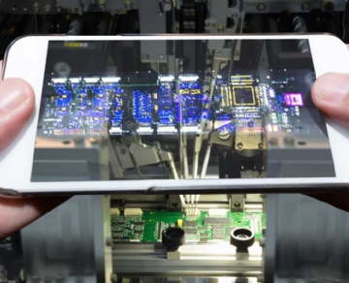
When you know more about it， almost all the electronic devices we use everyday contain some kind of semiconductor， and nitrogen is the key component to produce them. Since the middle of the last century， gas has been the top priority of the electronics industry. At that time， the earliest examples of commercial transistors and circuits began mass production. Today， several factors are driving gas consumption， but the most noteworthy is the scale of deployment of semiconductor manufacturing plants to meet the needs of large economies.
For many reasons， gases are an ideal element in the technical field - they are easy to store， easy to produce on site， and easy to transport high-quality nitrogen through simple and inexpensive pipelines to multiple points of use throughout the facility. In addition， it is easy to control the chemical reaction of gas at the molecular level. Therefore， nitrogen system has become a popular choice for semiconductor manufacturing. The following are some examples of nitrogen systems used in popular methods of semiconductor manufacturing:
Nitrogen film generator. This is a convenient turnkey system. It reaches your location， builds to your specifications， and is ready for you to go online.
PSA nitrogen generator. These systems effectively generate nitrogen by separating nitrogen from oxygen in the air around you.
Nitrogen bottle filling. Filling your own nitrogen cylinder is a cost-effective way to replenish the nitrogen supply. It exceeds the price of bottled gasoline.
So what increases the demand for these types of semiconductor manufacturing? The answer is simple: gadgets. Semiconductor manufacturers are staring at a severe challenge， the intersection of growing demand and decreasing cost demand. Not only are the devices in our pockets more complex than ever before， but there is a growing trend for fewer and fewer packages. The laptop is very thin， and our smart phone holds an information world in a package that can slide into the back pocket of the fitted jeans. Can semiconductor manufacturing keep up? If so， the nitrogen generator is a large part of the equation.
In order to meet the needs of a society increasingly dependent on smart phones， semiconductor manufacturers have been using nitrogen inert gas. Nitrogen can provide a larger process window with minimal oxygen safety， whether in stacking chips， reworking， or manufacturing solder bumps for components. According to the regulations， lead-free welding has appeared. The combination of chemical aggressiveness of flux and small delta T temperature window can make N2 inert and improve the production success rate. Controlled nitrogen atmosphere in reflow， wave soldering， selective and repair applications provides a greater workplace for engineers. Nitrogen is also helpful during the period when the solder finishes wetting the surface to obtain a liquid state with good adhesion.
As we become more and more dependent on smartphones， the demand for this form of manufacturing will continue to increase. In the field of gas， we strive to provide on-site nitrogen with the highest safety and forward-looking innovation to remain at the forefront of the fast digital world.

