Hydrogen purification equipment for metal treatment

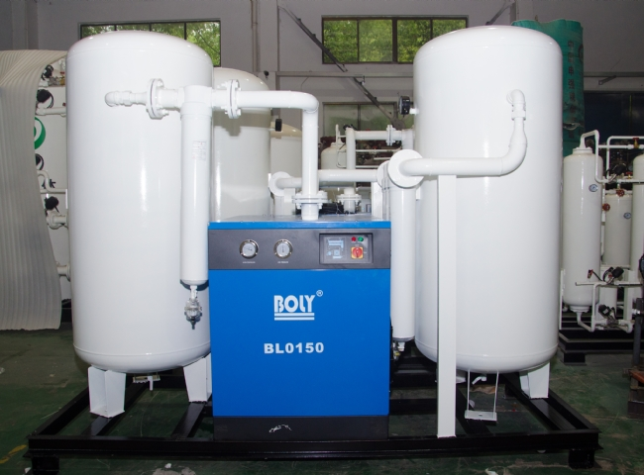
Purifier， Hydrogen purification system， H2 purifier
Suzhou XITE is a leading designer， manufacturer and supplier of PSA nitrogen generators， hydrogen generators， air dryers and purification systems. Metal treatment processes such as annealing and sintering require ultra-high purity hydrogen gas. Very often， commercial gas suppliers provide commercial cylinders that do not ensure this high purity. For critical processes， one must purify the commercial gas on their own site to ensure a continuous supply of high purity hydrogen.
On-site hydrogen can be produced by installing your own hydrogen generator capable of producing ultra-high purity hydrogen， or by purifying the gas from an existing source.
Uses of high grade hydrogen.
Flushing gas for semiconductor processing
Agricultural uses
Use as a catalyst in various industries such as pharmaceuticals
Atmospheres for high-temperature glass manufacturing
Clean fuel research
Specialty balloon manufacturing and supply

