Achieving efficient oxygen solutions with Suzhou XITE

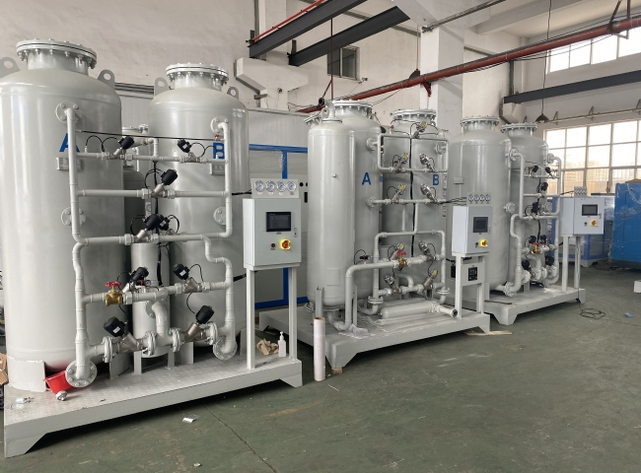
XITE is the best manufacturer of high quality PSA oxygen concentrators with over 6 years of experience in the field. We have served customers from all over the country and the world， establishing us as a large supplier in the manufacturing oxygen concentrator industry. We manufacture oxygen generators to produce oxygen suitable for industrial and medical use.
The capacity of our industrial oxygen generators ranges from one to two hundred cubic meters per hour. The oxygen pressure of our generators is 5 kg/cm2g. This value can be increased by adding a booster to the oxygen generation equipment. The purity of our industrial equipment is 95%， making it ideal for several industrial processes.
Industries that require oxygen.
Oxygen is indispensable for many manufacturing， extraction and refining processes. The following are some of the industries and sectors that require PSA oxygen generators for ongoing operations
Chemical manufacturing processes also use pure oxygen.
Glass manufacturing processes.
Paper manufacturing industries.
Oil and other petroleum extraction processes require oxygen.
Oxygen is an important element of waste management.
Pharmaceutical manufacturing processes utilize oxygen.
Healthcare services also depend on the supply of pure oxygen.
Suzhou XITE also manufactures medical grade oxygen generators to produce the pure oxygen needed for medical treatment. Our generators can produce oxygen that meets 93% ± 3% benchmark purity， meeting the requirements of the US， European and Chinese Pharmacopoeias. You can contact us for a PSA oxygen generator to meet your customized requirements and get a long lasting and cost effective solution.

