Special gas safety storage and transportation points to know early

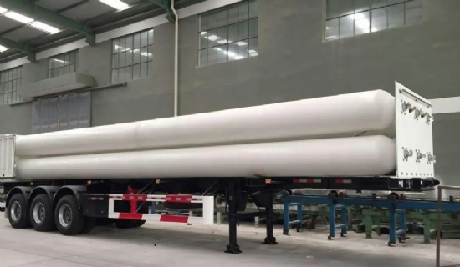
1. Dangerous goods should be transported in special vehicles， preferably with direct delivery from manufacturers and qualified escorts and porters who know what they are doing， and lightly loaded and unloaded.
2. Caps must be worn to avoid the danger of opening the bottle valve during the process of braking and loading and unloading， especially for the transportation of high purity hydrogen and other flammable gases.
3. It is forbidden to mix high purity oxygen， air and combustible gases. At the same time， fire and smoke are strictly prohibited， and fire extinguishing equipment should be provided on the means of transportation.
4. The transportation should be shaded in summer to avoid exposure to the sun.
5. There should be a special gas warehouse for storage. Gas cylinder warehouse should be ventilated， dry， clean， and avoid direct sunlight， and the cylinder warehouse should be clearly marked with the words "gas cylinder storage" and appropriate hazard markings (such as flammable， explosive， toxic， etc.).
6. There is a person responsible for the management， acceptance and verification， registration and issuance of the accounts can be checked.
7. Whether it is a warehouse or a place of use， empty cylinders and actual cylinders should be placed separately， and have obvious signs. Toxic gas cylinders and cylinder gas in contact with each other can cause combustion， explosions， toxic cylinders should be stored in separate rooms， and set up in the vicinity of anti-toxic appliances， fire-fighting equipment.
8. When placing gas cylinders should wear a good bottle cap. Properly fixed when placed on the stand， to prevent the inverted bottle touching the valve.
9. Gas cylinders should be protected from rust and erosion when used in the open air， and cylinders in stock should be checked regularly. If the color code， certificate of conformity， leakage， etc. are unclear or in doubt， the manufacturer should be contacted in time and analyzed and confirmed before use.
10. In addition， it is better to purchase gas according to the actual situation of production needs， so as to prevent the use of expired cylinders and reduce many unsafe factors.
Finally， it is recommended that units producing and selling petrochemical special gases wear anti-fouling caps on the mouths of their products when they leave the factory. It is suggested that the transport department should produce special cylinder transport vehicles.

