Application of nitrogen generator in heat treatment

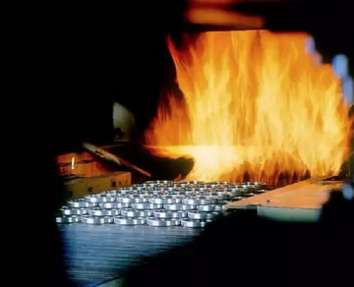
Nitrogen gas is a light， tasteless gas， which is very common and insignificant. However， without it， the heat treatment process would not be so effective. When our nitrogen generator produces this common gas with a purity of 95% to 99.999%， it helps to ensure a strong and beautiful end result， both in the kiln and in the furnace.
How can nitrogen make heat treatment more fruitful?
In the process of heat treatment， there are two things: heat and pressure. Whether metals or other materials are undergoing heat treatment， oxygen is the biggest competitor. Any metal whose temperature exceeds 600 degrees Fahrenheit will be oxidized if it comes into contact with oxygen. This will cause the product to change color and weaken its strength. Even if it appears to be intact after heat treatment， it will not be as strong and not very good-looking as when there is no oxygen.
The process of heat treatment with nitrogen
The heat treatment facility uses nitrogen to purify the oxygen in the air to ensure that its products will not come into contact with oxygen， resulting in damage to the products. By continuously supplying nitrogen through nitrogen generators (oxygen generators)， they can always keep the air free of oxygen and protect iron， steel and other metals from oxidation.
How can the on-site nitrogen generator system help the heat treatment company?
Since nitrogen is very important for heat treatment， it is obvious that insufficient nitrogen supply will have a great impact during heat treatment. Using the on-site nitrogen generator gas system (nitrogen generator) will perfectly solve the problem of nitrogen circulation supply. Enterprises can produce their own high-purity nitrogen on site through nitrogen generator， so we can rest assured that our nitrogen will never be exhausted.
In addition， heat treatment enterprises like the nitrogen generator of the on-site gas system， because they don't have to bother to arrange the purchase of nitrogen cylinders or worry about the storage of nitrogen， which leads to a series of systematic problems， such as nitrogen transportation， storage and， most importantly， capital expenditure.
Heat treatment enterprises especially like to use the nitrogen generator (nitrogen generator) of the on-site gas system， because it will save you a lot of unnecessary expenses. Nitrogen generator can not only quickly recover the initial investment cost of producing nitrogen， but also improve the product quality of enterprises， so as to reduce the capital wasted on waste materials.

