Medical Oxygen Concentrator

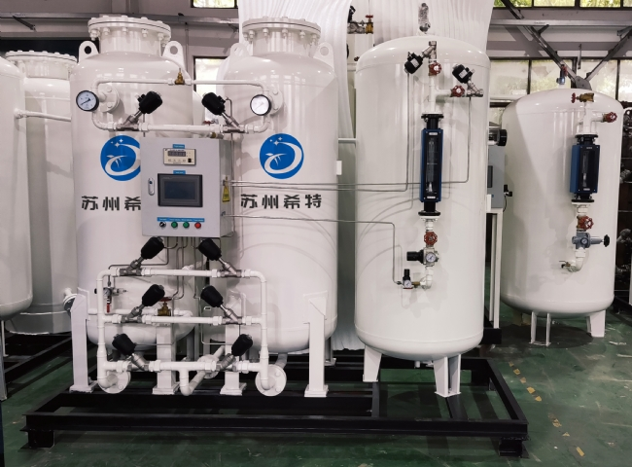
#GasGeneration， Medical Oxygen， Oxygen， Oxygen PSA
Schitt medical oxygen generators allow users to generate their own oxygen for their medical grade needs such as EMS (Emergency Medical Services)， ambulances， fire departments， small hospitals， clinics， nursing homes， dental lab applications. XITE uses PSA technology to compress atmospheric air， exclude other gases from it and separate out the oxygen.
Process of PSA oxygen technology
PSA type oxygen technology starts with an air compressor， which compresses the air in the atmosphere and increases the pressure of the air. Next is the oxygen generation unit， which consists of an air receiver tank. The air enters the air receiver tank and then passes through the air filtration system into the PSA (Pressure Swing Adsorption) tower. the PSA tower is filled with ZMS. when the pressurized air comes in contact with the ZMS， the ZMS absorbs the gases in the air other than oxygen. The oxygen， in turn， enters the surge vessel. As the pressure decreases， other gases enter the atmosphere through the exhaust. Some of the gas from the surge vessel enters the PSA tower for purging， and the remaining gas is sent to the storage tank via a rotameter. zMS is used in the oxygen generator to achieve a purity of 93%.
Advantages of on-site PSA oxygen generators
The PSA unit can be placed on site so that oxygen can be supplied whenever needed.
Very little space is required.
During downtime， there are fewer losses due to the short start-up time.
The user only needs to turn the start/stop button to get the oxygen at the designed flow and purity in a few minutes.

