Application of on-site nitrogen generators (PSA nitrogen generators， nitrogen equipment) in the mining industry

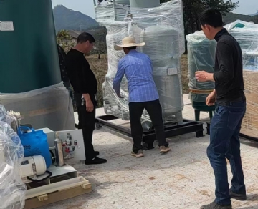
Nitrogen plays a vital role in the mining industry， and with a nitrogen generator (PSA nitrogen machine， nitrogen equipment) on site， a mine can be prepared for any situation that arises. Nitrogen is used in the mining industry for two main reasons.
Nitrogen is used for fire suppression
The main reason for keeping a nitrogen generator (PSA nitrogen machine， nitrogen equipment) at any mining site is to fight fires. For ecological and economic reasons， coal mine fires are a nightmare. In fact， fires in some coal mines can cost companies as much as $2 million per day. With nitrogen， fires can be easily extinguished.
By replacing the oxygen in the mine， the fire can no longer flourish. However， depending on the size of the fire， it can take days， weeks or even months of continuous nitrogen injection. This makes it necessary to have a nitrogen generator for coal mines (PSA nitrogen machine， nitrogen equipment). Our coal mine nitrogen generators are extremely portable， producing a steady supply of nitrogen that can be used in even the most remote locations.
Nitrogen for inerting abandoned areas
The Mine Safety and Health Administration requires that all sealed areas of a mine remain inert， or chemically inactive， to prevent any explosions in these areas. Another option is to use high-pressure containment. Nitrogen is used to replace oxygen until the air is less than 10% oxygen. As atmospheric conditions change， so does the air in many underground areas， resulting in increased oxygen levels. This may require a continuous injection of nitrogen. With an on-site coal mine nitrogen generator， nitrogen can be produced whenever it is needed， without having to wait for it to be delivered.

