Increasing demand for on-site nitrogen production in the aerospace industry

A key challenge for leaders in the aerospace industry is ensuring aircraft/mechanical safety. Nitrogen， due to its chemical inertness， has become an almost indispensable resource that can greatly enhance its safety in aerospace applications. This article will highlight the benefits associated with the use of on-site nitrogen production in aerospace industry production.
The Importance of Nitrogen to the Aerospace Industry
As mentioned earlier， equipment safety is a major concern for the aerospace industry. Nitrogen is an inert gas that retards spontaneous combustion by displacing oxygen. This flame retardant property makes it safe for use in a variety of aerospace and aviation applications.
What is the role of nitrogen in aerospace applications?
Gaseous nitrogen has been shown to be very beneficial in optimizing aerospace safety. Some of the key applications of nitrogen in aerospace are outlined below.
Aircraft Tire Inflation
Why are aircraft tires filled with nitrogen? Nitrogen's physical and chemical properties make it more suitable for tire inflation than ordinary compressed air. Aircraft tires filled with nitrogen handle better， leak less frequently， and have a much lower fire hazard due to their inertness.

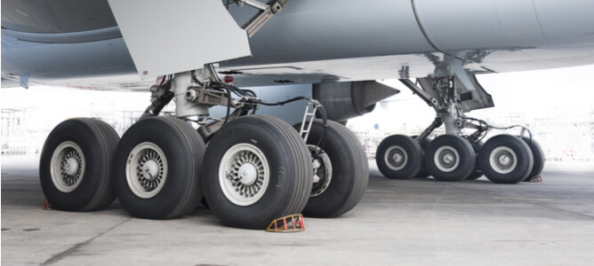
Aircraft fuel tank inerting
Aircraft often carry large amounts of fuel that carry a high risk of combustion. In addition to nitrogen for aircraft tire gas， fuel tank inerting is used to make aircraft fuel tanks stable. Nitrogen is often introduced into the fuel tank environment to minimize the chance of spontaneous combustion.
Oleo strut shock absorbers
One of the most critical points of aircraft flight is the landing phase. oleo strut shock absorbers play a key role in safely absorbing and redistributing landing loads. Nitrogen is the gas of choice for the compressor oil in these critical hydraulic systems as it optimizes their damping effect.

Escape slide inflation system
Escape slides/life rafts used in aircraft emergency evacuations are best inflated with nitrogen because it is stable and non-explosive. A standard nitrogen inflation system includes a pressurized gas cylinder regulated by a valve that can quickly inflate the life raft to fully evacuate the aircraft in less than two minutes.
Laser cutting/welding
The manufacture of aircraft components requires precise workmanship and does not allow for any errors. Airframe and engine components are manufactured using aircraft nitrogen service tools such as cutting lasers and welders. Nitrogen can be used in both processes to achieve a high quality finish.
Autoclave inerting
High-quality composite materials critical to aerospace/aerospace applications， such as the construction of fuselages and aircraft wings， are subjected to autoclave sterilization processes. The high temperatures and pressures required to perform industrial-scale autoclaving present significant combustion hazards that must be mitigated at all stages of component production. Inerting an autoclave with nitrogen gas can produce a stable environment in which an otherwise hazardous activity can operate without adverse events.
Benefits of Onboard Inerting Gas Generation Systems
Nitrogen has become almost indispensable in the aviation industry due to its integration in aircraft manufacturing， operations and turnaround activities. Here are some of the major benefits associated with the use of on-board nitrogen generation systems for aircraft
Gas Purity
The onboard nitrogen generator will produce a high purity gas that meets global aviation standards. In addition， the onboard nitrogen generator will consistently deliver the required amount of gas on demand.
Operating Conditions
Onboard nitrogen generation systems are built to withstand high temperatures and pressures. This is critical because the aircraft they serve often operate under harsh environmental conditions.
Cost-effectiveness
Onboard nitrogen generators are a cost-saving decision that eliminates the cost of cylinder procurement， storage， replenishment and transportation.
Flexibility in gas generation
An on-board nitrogen generator will allow the required amount of gas to be synthesized on demand. This means that gas synthesis can be scaled up or down at any time.
Time savings
On-board nitrogen production eliminates the possibility of supply chain delays common with supplier-supplied gases. However， cylinder-supplied nitrogen will be subject to stringent airport security checks. This translates into lost manpower time and reduced efficiency for a variety of aviation applications that rely on a steady supply of gas.

