Oxygen generator in the production process of lead-acid batteries

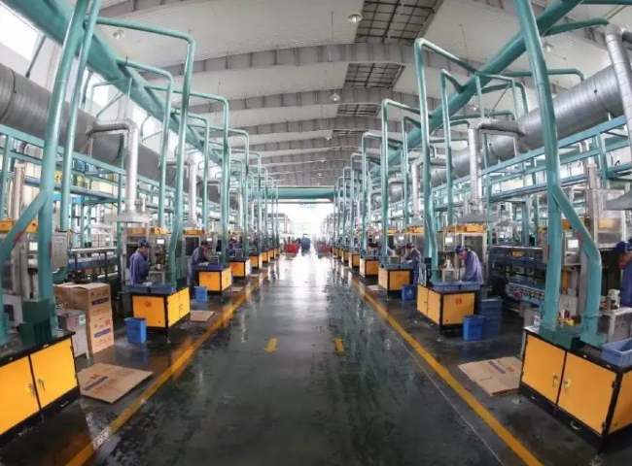
Seagate supplied a PSA type oxygen generator (PSA oxygen machine， oxygen generator) to a large battery manufacturer for their production facility in southern China.
The customer purchased the following specifications of oxygen generator equipment from XITE
Technology. Variable Pressure Adsorption (PSA)
Purity: 93%.
This was a complete turnkey supply of equipment with a dedicated air compressor. We also supplied 2 storage tanks for the oxygen produced， so that peak demand can be easily met.
Our customer， one of the largest manufacturers of lead acid batteries in southern China， previously used oxygen cylinders to fill their LPG flames for brazing of battery terminals. Oxygen is used to achieve higher temperatures and is critical for this industry to maintain cost control. Delivering oxygen through cylinders was not only expensive， but also very cumbersome. Brazing operators had to constantly worry about replacing cylinders， which impacted their productivity. Now with an on-site oxygen generator (PSA oxygen machine， oxygen generator)， it will run 24×7 and provide oxygen to the process continuously， thus increasing reliability and also improving the efficiency of this battery manufacturing plant.
We have supplied similar oxygen generators to many battery manufacturers in China and abroad. Talk to one of our experienced sales staff to learn how we can help your process with similar equipment.

