Nitrogen Generator Troubleshooting: A Simple Guide

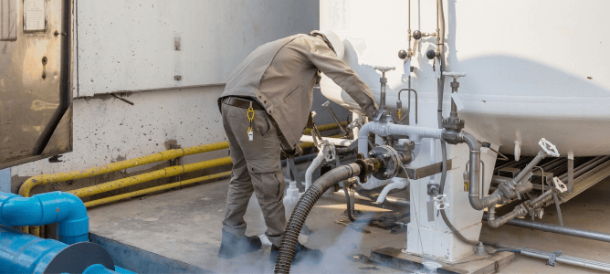
Nitrogen generators play a vital role in a variety of industries， from manufacturing to food packaging. They help ensure product quality and safety by providing a reliable source of nitrogen. However， like any other piece of machinery， nitrogen generators can encounter problems.
Common Problems with Nitrogen Generators
From time to time， nitrogen generators encounter problems such as
Low nitrogen purity
Reason: Inlet air pollution， filter clogging or membrane failure.
Troubleshooting: Check the air source and filter， clean or replace the filter， check whether the membrane is damaged.
Pressure fluctuation
Cause: Air leakage， valve failure or pressure regulator problem.
Troubleshooting: Check all connections for leaks， test valves， replace regulator if necessary.
Overheating
Cause: Overwork due to high demand or poor ventilation.
Troubleshooting: Ensure proper ventilation and monitor workload to prevent overheating.
Nitrogen generator will not start
Cause: Power supply problem， control panel problem， or sensor failure.
Troubleshooting: Check power connections， check control panel for error codes， and test sensors.
Advanced Troubleshooting
Sensor calibration problem
Cause: Sensor drift or calibration error.
Troubleshooting: Recalibrate the sensor according to the manufacturer's guidelines.
Software or Control Panel Problems
Cause: Software malfunction or control panel malfunction: Software malfunction or control panel malfunction.
Troubleshooting: Contact technical support for instructions or updates.
Leak Detection and Repair
Cause: Damaged seal or connection: Damaged seal or connection.
Troubleshooting: Use a leak detection solution or soapy water to locate the leak and replace the defective part.
If you encounter a problem that cannot be solved， seek professional assistance immediately.

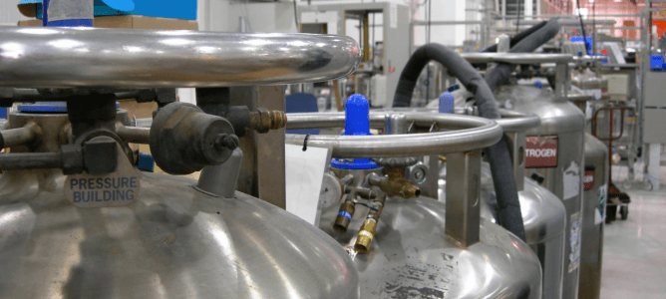
Preventive measures
Preventing problems before they occur is often more effective and economical than dealing with unexpected problems. In the case of nitrogen generators， taking preventive measures can help you maintain reliable performance and extend the life of your equipment.
Regular maintenance program:
Develop a comprehensive maintenance program for your nitrogen generator. The program should include routine inspections， cleaning， and replacement of filters， seals， and other parts as needed. Consistency is the key to preventing minor problems from becoming major ones.
Checks and Inspections: Start with the basics. Inspect the generator frequently for visible damage， loose connections or leaks. Prevention is often the high-quality cure.
CLEAN AND REPLACE FILTERS: Dust and contaminants can build up over time and affect the performance of the generator. Clean filters regularly and replace as needed to maintain efficiency.
MONITOR PRESSURE AND FLOW: Keep a close eye on pressure and flow to ensure it stays within recommended ranges. Sudden fluctuations may be a sign of a potential problem.
Recognize unusual sounds or vibrations: Unusual sounds or vibrations may be an early sign of a problem. Take prompt action to prevent further damage.
Operator Training
Make sure your team is well trained in the operation and monitoring of the nitrogen generator. Operators should be familiar with the unit's functions， troubleshooting basics， and safety protocols.
Spare parts and maintenance
Keep an inventory of necessary spare parts on hand at all times. This includes items such as filters， seals， valves and sensors. Having these parts on hand can professionally minimize downtime when maintenance or repairs are needed. Additionally， schedule regular maintenance on your nitrogen generator with a professional to address any wear and tear that may occur over time.
Documentation and Record Keeping
Keep detailed records of all maintenance activities， inspections and repairs. These records help track the performance of the equipment over time and provide valuable insight into recurring issues.
Air Quality Control
Ensure that the quality of compressed air entering the nitrogen generator meets the required standards. Filters and air dryers are important components for removing contaminants and moisture from the air supply. Regularly monitor and replace these components as needed to maintain high purity nitrogen.
Environmental factors
Pay attention to the environment in which the nitrogen generator operates. Adequate ventilation， temperature control， and protection from extreme conditions will help prevent overheating or other environmental stresses that could affect equipment performance.
Manufacturer's Recommendations
Follow the manufacturer's recommendations and instructions when servicing， maintaining and replacing parts. Nitrogen generator manufacturers provide instructions specific to their equipment to ensure optimal performance and safety.
By implementing these precautions， you can professionally minimize the risk of unforeseen problems with your nitrogen generator and provide consistent， reliable nitrogen production for your industrial or laboratory needs. Proactive maintenance and servicing can save you time， money and hassle in the long run.

