PSA nitrogen generators for laboratory， pharmaceutical and medical applications

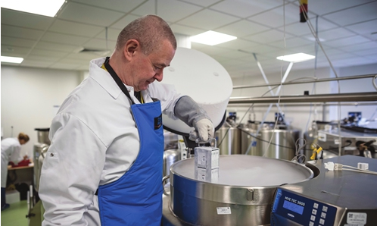
First， you should know that nitrogen generators are used to produce nitrogen (N2) for scientific and medical purposes. The manufacturing technology of variable pressure adsorption (PSA) generators enables the uninterrupted delivery of high purity nitrogen gas.
The technology uses one or two carbon molecular sieve beds (CMS) to remove oxygen and other contaminants from the atmosphere. The greatest advantage is designed to meet gas purity and flow requirements.
Many companies build high quality generators that are guaranteed to deliver high purity nitrogen. Most companies follow the highest safety standards， making the generators very safe for use where nitrogen production is performed at very low temperatures.
The company's engineers and technicians will ensure easy installation and safe operation. the return on investment (ROI) of the PSA laboratory nitrogen generator is very impressive and the customer will be able to break even within two years.
There is no need to order nitrogen cylinders and no need to worry about price increases. The generator helps produce high purity nitrogen and has an online purity monitoring capability for the equipment. The machine is also equipped with a digital counter that sounds when maintenance is required. In addition， the generator is equipped with the ability to shut down when nitrogen is not needed.
The latest technology and superb design are used to manufacture the PSA nitrogen generator equipment. This technology uses a combination of molecular sieves to selectively avoid oxygen and other contaminants in the atmosphere. CMS columns are first used for purification and then for regeneration to achieve uninterrupted nitrogen production.
How a PSA Nitrogen Generator Works and How it Works
The generator uses pre-filtered compressed air at a pressure of 102 or 123 pounds. The air is then filtered and passed through the CMS column， which acts as a purification unit where oxygen， carbon dioxide and hydrocarbons are removed from the compressed air.

