On-site nitrogen generators for food and pharmaceutical applications with unlimited nitrogen production

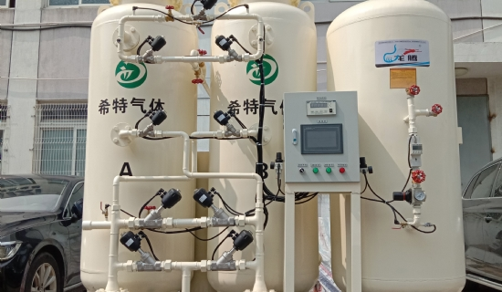
Nitrogen generators are manufactured to produce high purity nitrogen， which is taken from the surrounding atmosphere. It is undeniable that approximately 80% of the air we breathe is nitrogen， which provides an amazing business opportunity for companies that rely on nitrogen. That's why we build high-quality nitrogen generators that take the gas from the surrounding environment and increase its purity to 99.999%， which is sufficient for a variety of commercial requirements.
Producing high quality nitrogen on demand
In the past， companies used gaseous or liquid nitrogen cylinders to meet their requirements. This was fraught with delays due to logistical issues. This could cost your business a lot of money as people could not afford the delays. However， in installing a nitrogen generator plant， one can avoid the need for gas cylinders. This will also greatly reduce the cost and make your business more profitable. The generator can produce as much nitrogen as you need without interruption and for as long as you need the gas. We can also customize the generator according to customer requirements. It will produce a reliable supply of gas.
Storage with nitrogen refilling stations
For companies that rely on nitrogen cylinders， they may wonder how the nitrogen generator will meet their daily needs for nitrogen. However， we offer storage options for the generators. We offer a nitrogen filling station that people can use to refill nitrogen cylinders at any time. By using a nitrogen cylinder filling system， one always has the option to use the generator to fill the cylinders at any time. It goes without saying that filling your own cylinders will significantly reduce your costs. Our system requires minimal maintenance and will prove to be cost effective in the long run.
On-demand use and efficiency
There is no need to store additional cylinders， as the nitrogen equipment is capable of generating an uninterrupted supply of gas at your business location. The unit incorporates a cylinder filling system that facilitates the storage of additional cylinders. However， the option of storing additional nitrogen is always there.

