Compressed Air System in a Steel Plant

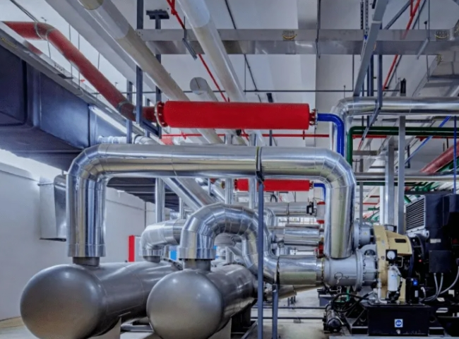
Compressed air systems in steel mills
Compressed air is air held under pressure at a value greater than atmospheric pressure (1.03 kg/cm2). It is a medium that carries potential energy.
Compressed air is a widely used tool in steel mills. It is an important source of air for instruments. In addition to instrument air， which is completely dry and free of contaminants， compressed air has three main uses in steel mills
Blast furnace air for blast furnaces
Oxygen， nitrogen and argon production for air separation plants
A practical gas with many uses. The most important of these is the operation of pneumatic devices.
Typically， the cold air for the blast furnace is supplied by a turbo blower or an electric blower. In air separation plants， special compressors are used to produce compressed air of the specifications required by the air separation plant for the production of oxygen， nitrogen and argon. In cases where compressed air is used as a utility gas， steel plants usually have a centralized compressed air system or/and a localized compressed air system.
Compressed air is an expensive utility when evaluated on a per unit of energy delivered basis. The advantage of using compressed air is that it can be easily stored in an air receiver and is readily available during short peak demand periods.
The conversion of electricity to compressed air is inefficient and there are line losses in the distribution of compressed air. Although the total energy consumption of such systems is usually small， compressed air systems are the most expensive energy source in steel plants due to their very low efficiency. A typical compressed air system has an energy efficiency of about 12 to 15 percent. A variety of measures can help compressed air systems operate at optimum effectiveness and reduce their energy consumption and costs.
Much of the production equipment in a steel mill is driven by cylinders. These include automatic feeders， chucks， clamps， presses， intermittent motion equipment (both reciprocating and rotary)， and many others. This type of equipment typically has a low air consumption. Tools and equipment operated by compressed air are often referred to as pneumatic equipment. Pneumatic equipment has a high output to weight ratio. They use air motors， which are smaller and lighter than electric or hydraulic motors， providing better ergonomics for the operator. They are ideal for tough applications， especially in hot， dirty environments and areas of frequent overloads. While pneumatic devices do require regular maintenance to maintain their maximum efficiency， they are extremely reliable and virtually indestructible under these conditions.
Cylinders used in pneumatic devices generally have a soft feature. Pneumatic devices simply stop working when the load exceeds the limit， whereas when electric and hydraulic drives are overloaded， they can cause both damage to the equipment and possibly injury to the operator.
The compressed air system consists of three main subsystems as follows. (Figure 1)
Compressor with drive and control， intercooling， compressor cooling， waste heat recovery， and inlet filtration
Conditioning and storage equipment， including aftercooler， receiver， separator， trap， filter， and air dryer
Compressed air distribution subsystems， including main lines， branch lines to specific users， valves， additional filters and traps， air hoses， possible supplementary compressed air conditioning equipment， connectors， and often pressure regulators and lubricators.

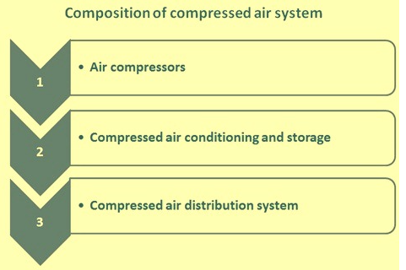
Figure 1 Composition of the compressed air system
Production of compressed air
Compressed air can be produced by two processes.
Dynamic compression， where the velocity of the air is converted into pressure. Dynamic machines use axial and centrifugal impellers to impart velocity to the air， which is then converted into pressure. Centrifugal and axial compressors are dynamic machines that typically operate at high speeds.
Displacement compression， which involves reducing the volume of air. Positive displacement machines use reciprocating piston， rotary screw or vane types to produce air compression. Screw， reciprocating and vane compressors are positive displacement machines.
Air compressors are usually rated in "free air" units， i.e.， at the pressure， temperature and relative humidity of the air atmosphere， not at the pressure， temperature and relative humidity of the pneumatic equipment to be operated. At the outlet of an air compressor， the air temperature is typically about 120 degrees Celsius to 130 degrees Celsius. Most modern air compressors have an aftercooler， located behind the compressor， as a standard accessory that performs the function of removing water and some oil vapor.
Air compressors are available in single or multi-stage compression. Multi-stage compression is usually used when the discharge pressure equals or exceeds 6 kg/cm2. Multi-stage compressors offer energy efficiency because the air is cooled between compression stages and the moisture is removed by cooling.
Most compressors are controlled by line pressure. Typically， a drop in pressure signals an increase in demand， which will be corrected by increasing the output of the compressor. An increase in pressure indicates a decrease in demand， resulting in a decrease in compressor output.
The total compressed air supply to a steel plant can be provided by a single compressor or multiple compressor installations， which can be centralized or decentralized. Single compressor installations are best suited for smaller systems or systems that operate almost exclusively at full output.
Multiple compressor installations offer a number of advantages， including (i) application flexibility (the ability to effectively adapt to changes in demand)， (ii) maintenance flexibility， (iii) the option of centralized or decentralized operation， (iv) floor space flexibility， and (v) backup capability.
Because not all compressors can be kept online at all times in a multi-compressor system， the actual gas supply at any given time may be less than the total system capacity. The stored compressed air can be used to prevent any pressure drop in the system for as long as it takes for the additional compressor capacity to come online. The required storage capacity depends on the excess demand in cubic meters， the available pressure differential between the compressor station and the point of use， the compressor start-up time， and the time to replenish the stored compressed air.
Compressed air production usually includes the necessary elements of compressed air treatment.
Compressed air treatment
Dryness and contaminant levels are two key factors used to differentiate low quality compressed air from high quality compressed air. There are three main considerations for the quality of compressed air required.
Professional moisture content or pressure dew point
Professional oil content
Professional particulate concentration
The atmosphere entering the compressor has some humidity or contains some water vapor. When the air is cooled in the cooler， much of this water usually condenses as it is discharged from the compressor. Moisture in compressed air can be liquid water， aerosols (mist) and vapors (gas). The most obvious and easiest to remove are water and aerosols， which can be removed by efficient filtration and refrigeration dryers. Water vapor is more difficult to remove and requires the use of a dryer (desiccant type) in conjunction with high efficiency filtration.
The general measure of air dryness is the dew point. The dew point is the temperature at which the air becomes saturated with water and the moisture begins to condense. Effectively lowering the dew point means that the system can tolerate lower temperatures before water droplets begin to condense.
Filtration is a key factor in the proper operation and performance of a compressed air system.
Removal of liquid and particulate contaminants is a basic requirement for filtration. However， requirements for vapor removal， ultrafine filtration and catalyst filtration are used in specialized applications.
Air filters can be located throughout the system， with the number and type of filters varying depending on the required air quality. Air filters are typically classified into the following two categories.
Pre-filters， which operate prior to compression and/or drying
Post-filters， which are put into service after the air has been dried
Inlet filters for air compressors are designed to protect the compressor， but are often not sufficient to protect downstream equipment. The compressor itself may add contaminants， including wear particles， carbon deposits and lubricants. These all need to be filtered. Filters should be selected based on flow rate and pressure drop rather than pipe size. Excessive pressure drops can lead to increased operating costs， short filter element life and an overall reduction in system performance.
Compressed Air Storage
An air receiver is a container that stores compressed air and acts as a buffer bank for short-term peaks in demand. It allows the capacity of the compressor to be temporarily exceeded. Typically， the system will run an auxiliary compressor to meet intermittent demand， compressor failure， or short-term energy interruptions. The installation of an air receiver allows this compressor to be shut down.
Air receivers create more stable pressure conditions. They serve to dampen compressor pulsations and separate out particles and liquids. They make compressed air systems easier to control and additionally act as secondary cooling units and condensate collectors. A larger reservoir can be installed to meet occasional peak demand， and even a smaller compressor can be connected.
In most systems， the receiver is usually located before the dryer because the buildup in the receiver is cooled and enough condensate is discharged. This reduces the load on the dryer and thus increases the efficiency of the dryer. Alternatively， multiple receivers can be used， one before the dryer and another near the intermittent/high demand point.
Compressed air distribution and systems
When properly designed， installed， operated and maintained， compressed air distribution systems are a major source of power with many inherent advantages. Compressed air is safe， economical， adaptable， easy to transfer， and provides labor-saving power.
The primary purpose of a compressed air distribution system is to deliver compressed air from its point of production (the compressor) to its point of use (the application) in sufficient quantity and quality and at sufficient pressure to allow pneumatic equipment to operate efficiently. The ideal distribution system provides an adequate supply of compressed air at the required pressure to all places where it is needed. However， there are many other factors that need to be considered in the design of the system to ensure the efficiency and safety of the overall system. These factors include the following.
Compressed air volume and flow rate requirements
Air pressure requirements and peak air demand
The type and number of compressors and their configuration
Piping and its size and type of material
The quality of compressed air required at each point of use and the demand for each quality
Efficiency of the compressed air system
Safety of the compressed air system
The layout of the compressed air system
Compressed air and ambient temperature at the filtration point
Configuration of the compressed air dryer
Isolation valves in the system
Compressed air needs to be delivered to the point of use at the required pressure and in the correct condition. Too low a pressure can affect the efficiency of the pneumatic unit and impact process time， while too high a pressure can damage the pneumatic unit and can lead to leaks and increased operating costs. It is usually a balancing act and getting it "just right" can result in good savings for the equipment. Here， flow rate considerations at the point of use are much more important. A properly sized receiving tank can also provide sufficient storage capacity for any peak in demand. During peak demand periods， a poorly designed system can experience pressure drops as air in excess of the system capacity is pulled from the system.
Compressed air distribution piping is the means of transporting compressed air and serves as the link between supply， storage and demand. A network of piping is used to supply compressed air to different locations. However， the flow of compressed air through the piping creates friction， resulting in pressure drops. Ideally， the pressure drop in the pipeline should not exceed 0.1 to 0.2 kg/cm2.
The following steps are usually taken to reduce the pressure drop.
Reduce the distance that compressed air must travel
Reduce friction through the piping by increasing the pipe size and avoiding unnecessary elbows， valves and other flow restrictions
Reduce the flow rate of compressed air through the system
Use smooth bore piping
Minimize pressure drops between system components professionally
Avoid leaks
Frictional losses are higher in longer pipes and smaller diameter piping. An effective way to reduce pressure drop is to use a recirculating system that provides bi-directional flow at any point in the system， cutting the flow rate in each duct path to half and reducing the velocity of the compressed air.
More important than the friction-induced pressure drop， however， is the pressure drop generated by the system components themselves. This pressure drop is typically around 0.4 to 1.5 kg/cm2. This pressure drop can be controlled by careful equipment selection and proper maintenance of the compressed air system.
Piping is critical to the reliability and efficiency of the compressed air system. Material selection， size， layout， site conditions and future needs are factors to consider before laying piping. Piping needs to be strong enough to accommodate existing operating conditions， provide minimal possible pressure loss and leakage， and be easy to maintain. Piping for compressed air lines can be black， galvanized， copper or stainless steel piping. Each type of piping has advantages and disadvantages that should be carefully evaluated.

