The importance of oil and water separators for air compressors

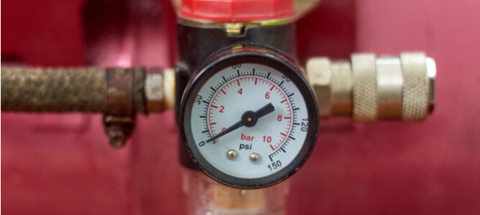
Air compression systems play a key role in many industrial production cycles. While they are highly beneficial to the manufacturing industry， poorly maintained air compressors can be damaged by the build-up of contaminants during production activities. An oil-water separator will effectively optimise the compressed air system while maintaining compliance with environmental industrial waste disposal regulations.
What is an oil-water separator?
An oil-water separator is a device used to eliminate waste oil generated during industrial production activities. Sometimes referred to as a condensate separator， this device helps to separate oil and other lubricants from the condensate that forms during industrial-scale air compression. This enables operators to discharge oil-free water， allowing them to comply with municipal wastewater treatment regulations.
How does the oil-water separator work?
An air compressor oil and water separator is very simple to set up， requiring only a single manifold connection between it and the source of condensate. The water produced during air compression activities is usually collected in the following components
Aftercooler
Air drying system
Receiving tank
Air filter
Condensate collector
Once the water has been introduced into the separator from the different sources， the filtration process can begin.
Components of an oil and water separator
The main components of an industrial oil and water separation unit are.
Connection channels
Cyclone decompression chamber
Filter cartridges
Activated carbon system
Outlet drainage unit
Oil and water separation processes for air compressors
Oil-water separators for industrial air compression systems usually combine adsorption and absorption processes to remove oil from the waste water. The main steps of the filtration process are outlined below.
Condensate is conveyed through channels connecting the air compressor and separator to the cyclone decompression chamber， where any accompanying air is discharged. This provides power to the oil-water mixture and makes the filtration process more efficient.
The liquid mixture is allowed to drain by gravity onto a filter cartridge made of polypropylene fibres. This constitutes the suction phase of the separation， as most of the oil is retained in the fibres of the filter.
The largely oil-free water is then exposed to the activated carbon material， which eliminates any residual oil by adsorption. Activated carbon filters are made up of micro-pores with oleophilic walls that retain the oil and lubricants that pass through them.
Once the water has left the carbon filter， it can be safely discharged or reused in the appropriate process.
Benefits of oil and water separation systems for air compressors
From a legal， environmental and economic point of view， there are many benefits to the treatment of condensate generated in industrial production activities. The following outlines the main benefits of using oil and water separators in air compression systems.
Compliance with environmental protection regulations
Oil and waste water can have a significant negative impact on the environment， with soil and water contamination being the main issues. The use of efficient oil and water filtration systems enables air compressor operators to prevent environmental pollution. This also enables them to comply with environmental protection regulations in the regions where their industry is located.
Recycling of oil and water
From an economic point of view， resource conservation and reuse can save companies high operating costs. Recycling water and oil from production activities can reduce energy and utility bills.
For example， oil generated by the food materials processing industry can be reused as a raw material for biofuels and tyre manufacturing. In addition， recycled waste water can be used to cool and clean industrial systems.
Extending the life of equipment
Uncontrolled build-up of water and other contaminants in air compressor systems can cause damage to sensitive components and lead to expensive but avoidable equipment downtime. Investing in oil and water separators for air compression systems prevents frequent breakdowns and extends the life of the equipment.

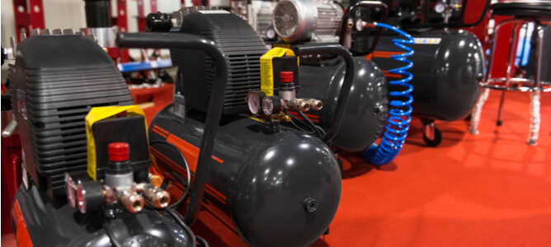
Oil and water separator regulations
In the United States， the Environmental Protection Agency (EPA) regulates the disposal of wastewater and oil generated in industrial processes. The agency requires that industrially generated condensate is either properly treated to eliminate petroleum contaminants or properly disposed of in accordance with prescribed regulations.
While condensate from industrial sources is primarily regulated under the Clean Water Act of 1970， the relevant sections of the Code of Federal Regulations also provide guidance to industrial operators.
Maintenance tips for oil and water separators
Maintaining oil and water separators is a relatively simple task and can be scheduled with three different levels of care.
Check the nature of the water flowing from the separator unit on a weekly to monthly basis. Very cloudy water indicates the need to replace the filter element.
Monthly to quarterly checks to assess the level of sludge in the separation tank.
Quarterly to annual maintenance includes replacement of the oil filter cartridge and activated carbon unit.

