How do nitrogen generators for fire sprinkler systems work?

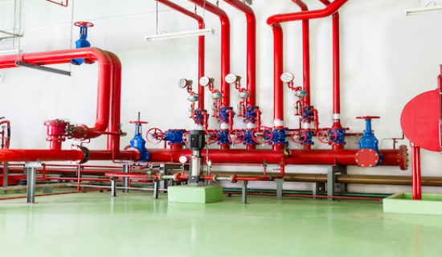
To mitigate the risk of fire outbreaks， building codes often require well-maintained fire sprinkler systems. Unfortunately， these fire protection systems are easily subject to corrosion from exposure to oxygen. To improve service life， the piping of sprinkler systems can be inerted using nitrogen. In this article， we will discuss how nitrogen generators can be used to enhance sprinkler systems.
The Dangers of Corrosion in Fire Sprinkler Systems
Fire is a costly event that can lead to property damage and psychological stress for those involved. To limit the impact of these unwanted situations， we use functional fire suppression systems.
The specialist dangers of corrosion within a fire sprinkler system are the build-up of rust and the blockage of passages. This means that when a fire breaks out， the sprinkler system will not be able to put it out because its water passages are blocked. Other effects of corrosion include costly temporary downtime and an overall reduction in productivity.
Advantages of nitrogen generators in fire sprinkler systems
How do nitrogen generators work in fire sprinkler systems? There are several advantages to integrating a nitrogen generator into a fire sprinkler facility.
Removal of oxygen
An important advantage of integrating fire sprinklers with nitrogen generators is the avoidance of oxygen in the sprinkler piping. The nitrogen delivered through the sprinklers will replace the oxygen in the piping， thus leaving the system inert and significantly delaying the onset of corrosion.
Reduced frequency of maintenance
A direct consequence of reduced corrosion in nitrogen sprinkler systems is that equipment will be maintained less frequently than non-nitrogen generators. The use of nitrogen generators in fire sprinkler systems can reduce corrosion by up to 98%.
Environmentally friendly fire retardant effect
Nitrogen is a naturally occurring compound. Nitrogen makes up a large percentage of the air around us. If it is used in a balanced mixture， the use of nitrogen is not harmful to the environment.
Cheap and readily available
As mentioned earlier， nitrogen is present in large quantities in the air we breathe. This makes it easy to obtain and a cheap source of inert gas for sprinkler systems. Once installed， the nitrogen generator will provide a large amount of gas in a cost-effective manner.
Increase the life of your fire suppression system
Using a nitrogen generator for your sprinkler system will increase its overall durability. The nitrogen will inert the piping， retarding corrosion and giving the sprinkler heads a much longer life before they need to be replaced.

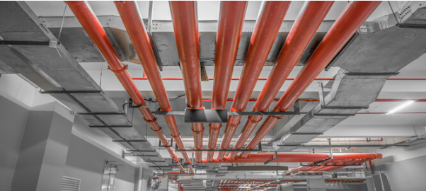
Things to consider when choosing a fire hose nitrogen generator
Each building has its own unique setup and requires a cost-effective fire suppression system that can perform effectively in the event of a fire outbreak. The following outlines the key factors to consider before deciding on a nitrogen generator fire protection facility
Estimated life of the building
This is a key factor in deciding whether additional nitrogen generator fire protection is required. While a nitrogen generator for fire sprinklers is a wise choice for buildings intended to be used for a longer period of time (60 years and beyond)， cheaper alternatives may be more appropriate for use in structures intended to be used only for a short period of time.
Maintenance Plans for Installed Fire Sprinkler Systems
Although nitrogen generators for sprinkler systems are designed to improve their life span， they do not replace regular maintenance. Nitrogen fire suppression systems should only be used with fire sprinklers that have been properly and regularly maintained to prevent corrosion build-up and pipe leakage.
Pipe Replacement and Nitrogen Producer Integration
From a financial perspective， integrating a nitrogen generator with a fire sprinkler piping system should be the right choice. Another key factor in deciding whether to install one is the overall cost， both short and long term.
It has been calculated that the cost of maintaining a nitrogen generator for a dry sprinkler system should be less than the estimated budget for repair or replacement of worn parts.

