Oxygen Concentrator for Chemical Industry (PSA Oxygen Concentrator， Oxygen Concentrator)

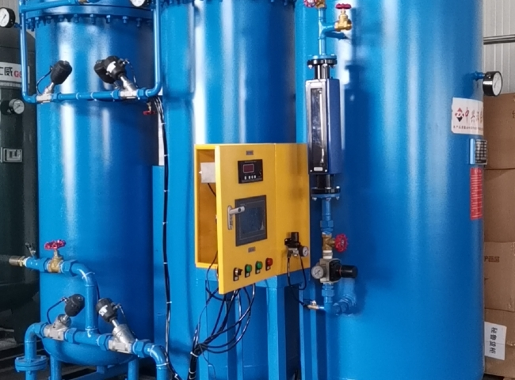
Gas generation， Oxygen， Oxygen PSA
An oxygen generator (PSA oxygen machine， oxygen concentrator) is a device that concentrates oxygen from a gas source (usually ambient air) by selectively removing nitrogen to provide an oxygen-rich product gas stream. Oxygen concentrators typically use variable pressure adsorption (PSA) technology and are very widely used for oxygen supply in healthcare applications， especially where liquid or pressurized oxygen is too dangerous or inconvenient， such as in homes or portable clinics. Our oxygen generators are based on a patented implementation of Pressure Swing Adsorption (PSA)， using ambient air as a feedstock.
Ambient air contains 21% oxygen， 78% nitrogen， 0.9% argon and 0.1% rare gases.The PSA process involves the static separation of the gases in the air through a specific molecular sieve designed to adsorb nitrogen under pressure to produce oxygen-rich air consisting of more than 93% oxygen.

