Air compressor has to say the three filter high imitation problem

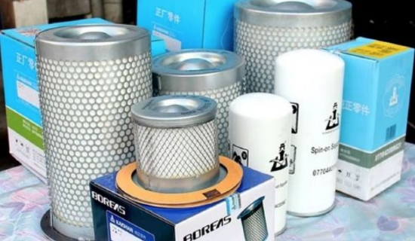
What is high imitation? The high imitation talked about in this article refers to the counterfeit products with labeling and fair quality， which are more or less sensitive when talking about this issue， and many people are reluctant to mention it. Today we don't talk about the right and wrong of high imitation， if we only discuss the surface right and wrong， it can't reflect the depth of the problem seen by this magazine. Let's think about it， why are there high imitations? Why is the proportion of domestic brands high imitation small?
If our agents are using air compressors themselves， and you choose a triple filter， would you choose the original one， or the high imitation one， or the alternative triple filter? If you want to understand this problem， we first analyze the market.
First， the current air compressor three filter high imitation of the three characteristics
1， high imitation of the three filters are mostly imported brands.
2， the profit margin of high imitation products will be much higher than the genuine product.
3， the quality of high imitation products as long as good， there is basically no impact on the use of customers.
Second， the brand manufacturers， agents， high imitation manufacturers， end users of their respective positions and interests
1、The position of brand manufacturers
①The use of the original logo of the three filters to ensure the compatibility and quality stability of the product， is an indispensable part of product quality assurance.
Using the original three filters， manufacturers can gain monopoly profits in the aftermarket.
2， the positioning of the end user
The first type of customers: choose the original factory can guarantee the quality， non-original product quality is not controllable， and to avoid machine failure and manufacturer tug of war， so choose the original factory.
② The second customer type. If the quality can be guaranteed， will also consider the non-original factory.
3， the positioning of high imitation manufacturers
There is a certain demand for high imitation in the market， but the risk is high.
The profit is higher compared with normal products.
4、The status of agents
The original parts are good， non-brand agents may not have good access to the goods and the purchase price is too high， the profits earned by the manufacturer are high and the agent's profit is meager.
② alternatives affordable price， quality can also be guaranteed， such as the user does not have special requirements， the basic recommended alternative brand three filters.
③If the customer insists on brand original three filters or wants to earn high profit， if the original three filters have low profit margin， high imitation products can be considered， but there are also risks.
Third， from the above respective positions and interests to analyze the reasons for the existence of high imitation products
1， some brand manufacturers in order to earn a lucrative aftermarket profits， the huge profit margin of the purchase price and sales price has become the soil for the existence of high imitation.
2， non-original agents require the original brand three filter channel is not good or manufacturers to protect agents caused by.
3， some agents are driven by interests to high imitation products for profiteering and guide end users to use.
4， China's intellectual property protection is not enough.
5， in the case of non-original agent purchase price is too high， and the profit is very thin， will consider high imitation three filters.

