The transport of industrial gases also has many requirements

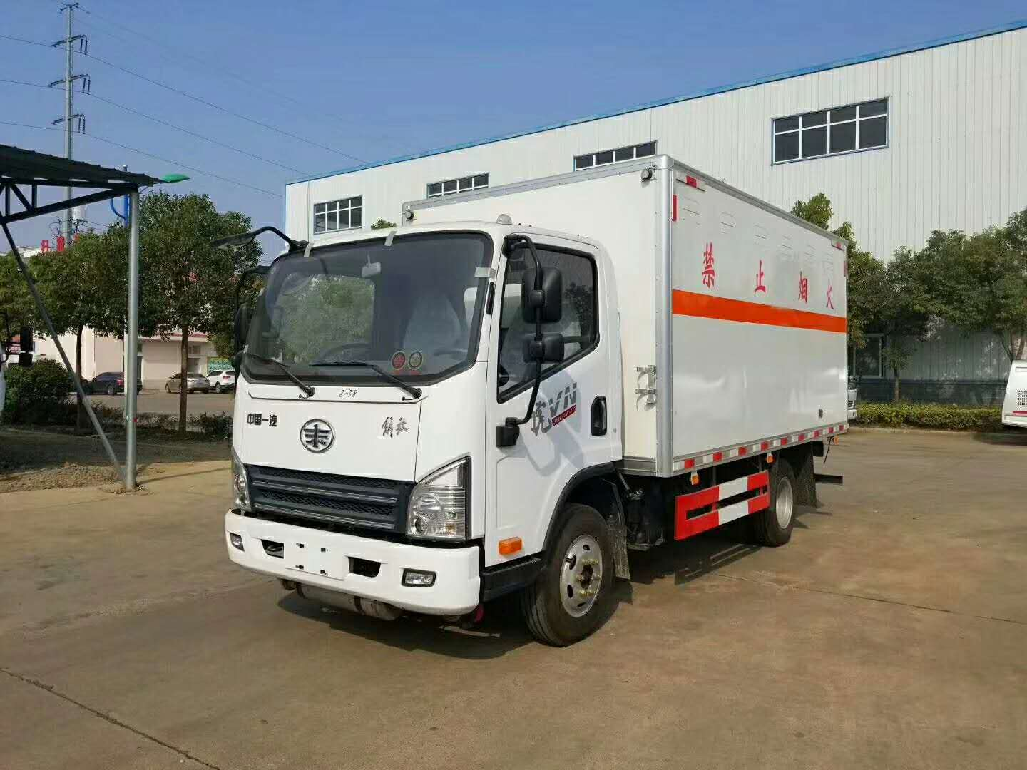
Industrial gases often face transport problems and need to be handled in accordance with regulations and procedures. The gas is prone to leakage and can cause serious injury. There are also many requirements for the transport of industrial gases in Dangyang. Units and individuals using gas cylinders are not allowed to repair or replace bottle valves， fusible plugs and other accessories， and welding and repairing gas cylinders in use is strictly prohibited. The gas in the cylinder can not be completely used up. Cylinders that will cause combustion and produce poisonous gases when the gases in the cylinders come into contact with each other shall not be transported in the same vehicle. Do not store in the same room with oxygen cylinders， gas cylinders and flammable materials.
The storage area for cylinders should be relatively dry and well ventilated. Open flames and other heat sources are strictly prohibited. Do not smoke in the vicinity of flammable gas or oxygen cylinders. Cylinders should not be exposed to sparks， flames， heat or electrical circuits. Designed to withstand only normal industrial transport. If subjected to strong vibrations， shocks or tipping， they can be damaged or even rendered unusable. Do not allow the Dewar's cylinder to fall during storage， transport and use and always keep the Dewar's cylinder upright. The low temperature of liquefied gas makes it easy to cause injury.
Gas filling stations should strictly observe the safety operation procedures. It is forbidden to use other gas cylinders to fill oxygen， and it is not allowed to use oxygen filling cylinders to fill other gases. All kinds of high-tech research and testing are inseparable from industrial gases， such as meteorological chromatograph， mass spectrometer， atomic absorption instrument， etc.; nuclear test industrial gases， nuclear energy， alarm， leakage detection， chemistry， electronics， etc. are inseparable from industrial gases; industrial gases are more and more widely used in the equipment manufacturing industry; as a comprehensive means and medium， industrial gases are widely used in the manufacture of moulding and protection， so as to achieve specific production requirements and objectives.

