Oxygen cylinder filling row

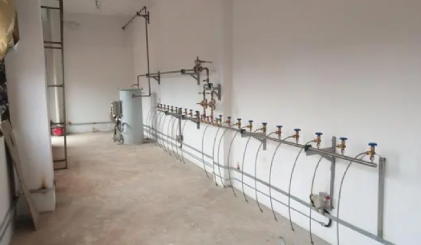
Have you ever thought about installing an oxygen cylinder refill station on your own hospital premises? Sounds like fun， right? After years of research and development， XITEch Technologies has come up with an excellent solution that not only fills your medical oxygen cylinders on hospital premises， but also provides sufficient medical oxygen during peak demand periods. Medical oxygen is one of the most important needs of hospitals. A shortage of its supply can cost precious lives. There have been many incidents of oxygen supply shortage in the past. This situation completely deteriorated the reputation of the hospital and affected their business in the long run. Therefore， a continuous supply of medical oxygen is necessary for both patients and hospitals， and for this reason， a continuous supply coupled with a reliable source is also important. The picture above shows the medical oxygen generator that will be used to make the oxygen cylinder filling station project. Hospitals often deal with their oxygen cylinder suppliers to meet their additional oxygen needs， but hospital management does not realize that this process actually makes oxygen cylinders expensive because administrative， transportation and storage costs are also added to their price. Sometimes all the medical oxygen is consumed during peak demand periods， in which case the supplier may not be able to supply the oxygen immediately. After all， he is not Superman and he needs some time to arrange oxygen cylinders. Inadequate supply of oxygen to a hospital can be a very dangerous situation， therefore， it is important for the hospital to have a permanent supply.
How can we help with oxygen cylinder refilling stations?
In order to have a continuous and sufficient supply of oxygen at a reasonable price， installing an oxygen cylinder filling station in your own hospital is the high-quality solution. Cylinder filling stations not only cover the disadvantages of local cylinder suppliers， but also offer the advantage of being paid. Therefore， in the long run， your profits and goodwill will increase if you install an on-site oxygen cylinder filling station.
What are the components of an on-site oxygen filling station?
Primarily， there are two components of an oxygen filling station that will provide you with real-time oxygen without the hassle. These components are
Medical Oxygen Concentrator
The Medical Oxygen Concentrator is a new age technology that provides medical oxygen directly to the hospital through a pipeline of which you will be the sole owner. Medical oxygen generators suck up the air present in the atmosphere and separate it from other gases. This technology is called Pressure Swing Adsorption (PSA) technology. The separated oxygen is transported to a storage tank and from there it is supplied directly to the pipeline.
The medical oxygen generators we offer have several advantages.
The medical oxygen generator uses atmospheric air and electricity， which is readily available to hospitals * It has been carefully designed and modified to provide an uninterrupted supply of oxygen. * It has a return on investment of less than 18 months， which means that the cost of the machine is quickly covered. * It is compact and customizable in size， which means it can be adjusted to your space availability. * It meets the standards for purity and medical oxygen grades set by the world pharmacopoeia. * It is completely reliable and provides guaranteed safety. A medical oxygen machine will ensure that your hospital will never run out of oxygen. Therefore， replacing it with an oxygen cylinder will solve your medical oxygen related requirements.
High pressure oxygen booster compressor for cylinder filling
The high pressure oxygen booster for cylinder filling is another component that offers some outstanding features. The oxygen booster automatically fills oxygen cylinders at a pressure of 150barg without any hassle. Installing a medical oxygen generator with an oxygen booster will avoid the need to order oxygen cylinders from a supplier.
You may be wondering， if you already have a medical oxygen generator， do you still need an oxygen compressor booster?
In the event of a natural disaster/natural calamity.
Medical oxygen is very important to hospitals and its backup should always be there in the worst case scenario. For example， in the event of a natural disaster such as an earthquake， the city will typically be without power for a few days. This situation may stop the medical oxygen generator from working (when you don't have a diesel generator). Hospitals should not face any problems because oxygen boosters help to store medical oxygen in cylinders in advance， so the medical oxygen in the cylinders can be used later. Therefore， if your hospital is located in an earthquake or hurricane prone area， then this technology will be very beneficial for you.
Peak demand.
Another demand for oxygen boosters is during peak demand periods. Hospitals do not need the same amount of oxygen at every point in time or every second or hour. Hospitals only use most of their medical oxygen during surgery hours. In this case， medical oxygen generators and oxygen cylinders will be needed to meet the peak demand for oxygen. The oxygen booster will play its role by continuously filling the oxygen cylinders with oxygen at 150 bar pressure. Therefore， you will never run out of oxygen.
Supply interruptions from your supplier.
If your oxygen cylinder supplier interrupts the supply of oxygen cylinders， an oxygen booster is the most reliable and efficient option your hospital can have. You can even rely on this machine completely without having to order oxygen cylinders from an outside source， as it can meet all medical oxygen requirements.
Price increases and supplier payment issues.
The oxygen booster fills cylinders at a more economical price. In the event of a natural disaster or other emergency， local oxygen cylinder suppliers may or may not be able to provide oxygen cylinders， but a medical oxygen booster will certainly work in any situation. You only have to invest in the machine once and then you can enjoy the profits for at least 10-15 years without any hassle. An oxygen cylinder filling station in your hospital will save you time， money and effort. By automating your oxygen supply system， you will have plenty of time to focus on other critical matters. Therefore， you should not delay any longer in contacting us and we can help you to install cylinder filling station in your hospital.

