Nitrogen in food preservation

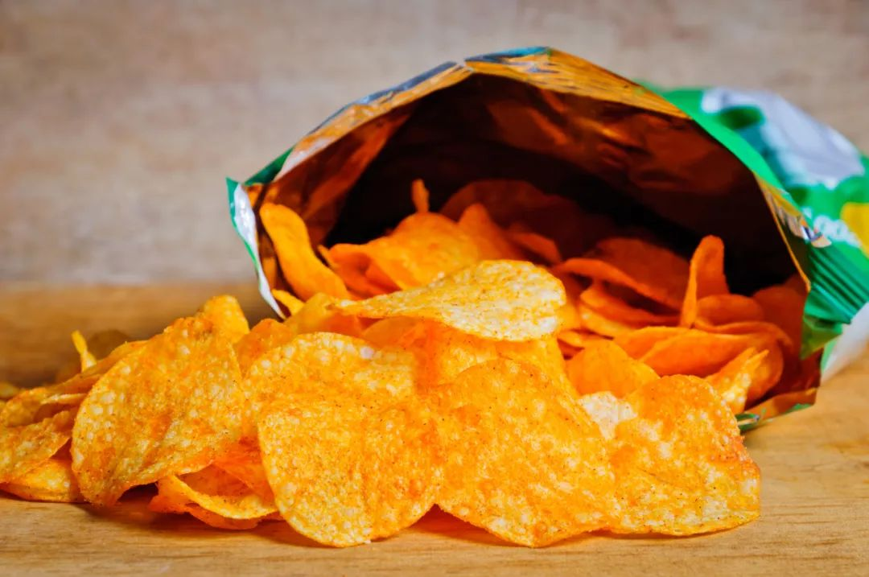
Nitrogen， also known as nitrogen， is an inert gas. Occupying 78 per cent of the atmosphere， nitrogen is one of the major constituents of air. Nitrogen can be prepared by liquefying or compressing the gas. Liquid nitrogen has a boiling point of -196°C and is a gas at room temperature and pressure.

Nitrogen has many advantages， the main one being that it is very stable and does not react with other substances. Nitrogen is used as an inert gas to protect substances that are susceptible to oxidation or corrosion. In addition， nitrogen is used as a propellant， refrigerant and fire extinguishing agent. Due to its properties， nitrogen is also widely used in industrial production.

Nitrogen has most applications in many different applications. Here are some of the main uses of nitrogen: Nitrogen can be used for food preservation as it prevents food from spoiling. It will be injected into food packaging to reduce the oxidation of food by air. It can be used in metal fabrication because it prevents oxidation. Nitrogen is used as a protective gas to protect metals being manufactured. Nitrogen can be used in medical applications such as anaesthesia and as a refrigerant. In anaesthesia， nitrogen is a commonly used anaesthetic and can be used in surgical or dental operations. In refrigerants， nitrogen can be used to freeze tissue or organs for surgery. Nitrogen can also be used in electronics manufacturing as it protects electronic components from oxidation.

Nitrogen is a widely used gas with many advantages and uses. Nitrogen is an ideal choice for many industrial and scientific applications because it is stable， non-flammable， non-reactive， and because it can be used to protect substances and components.

